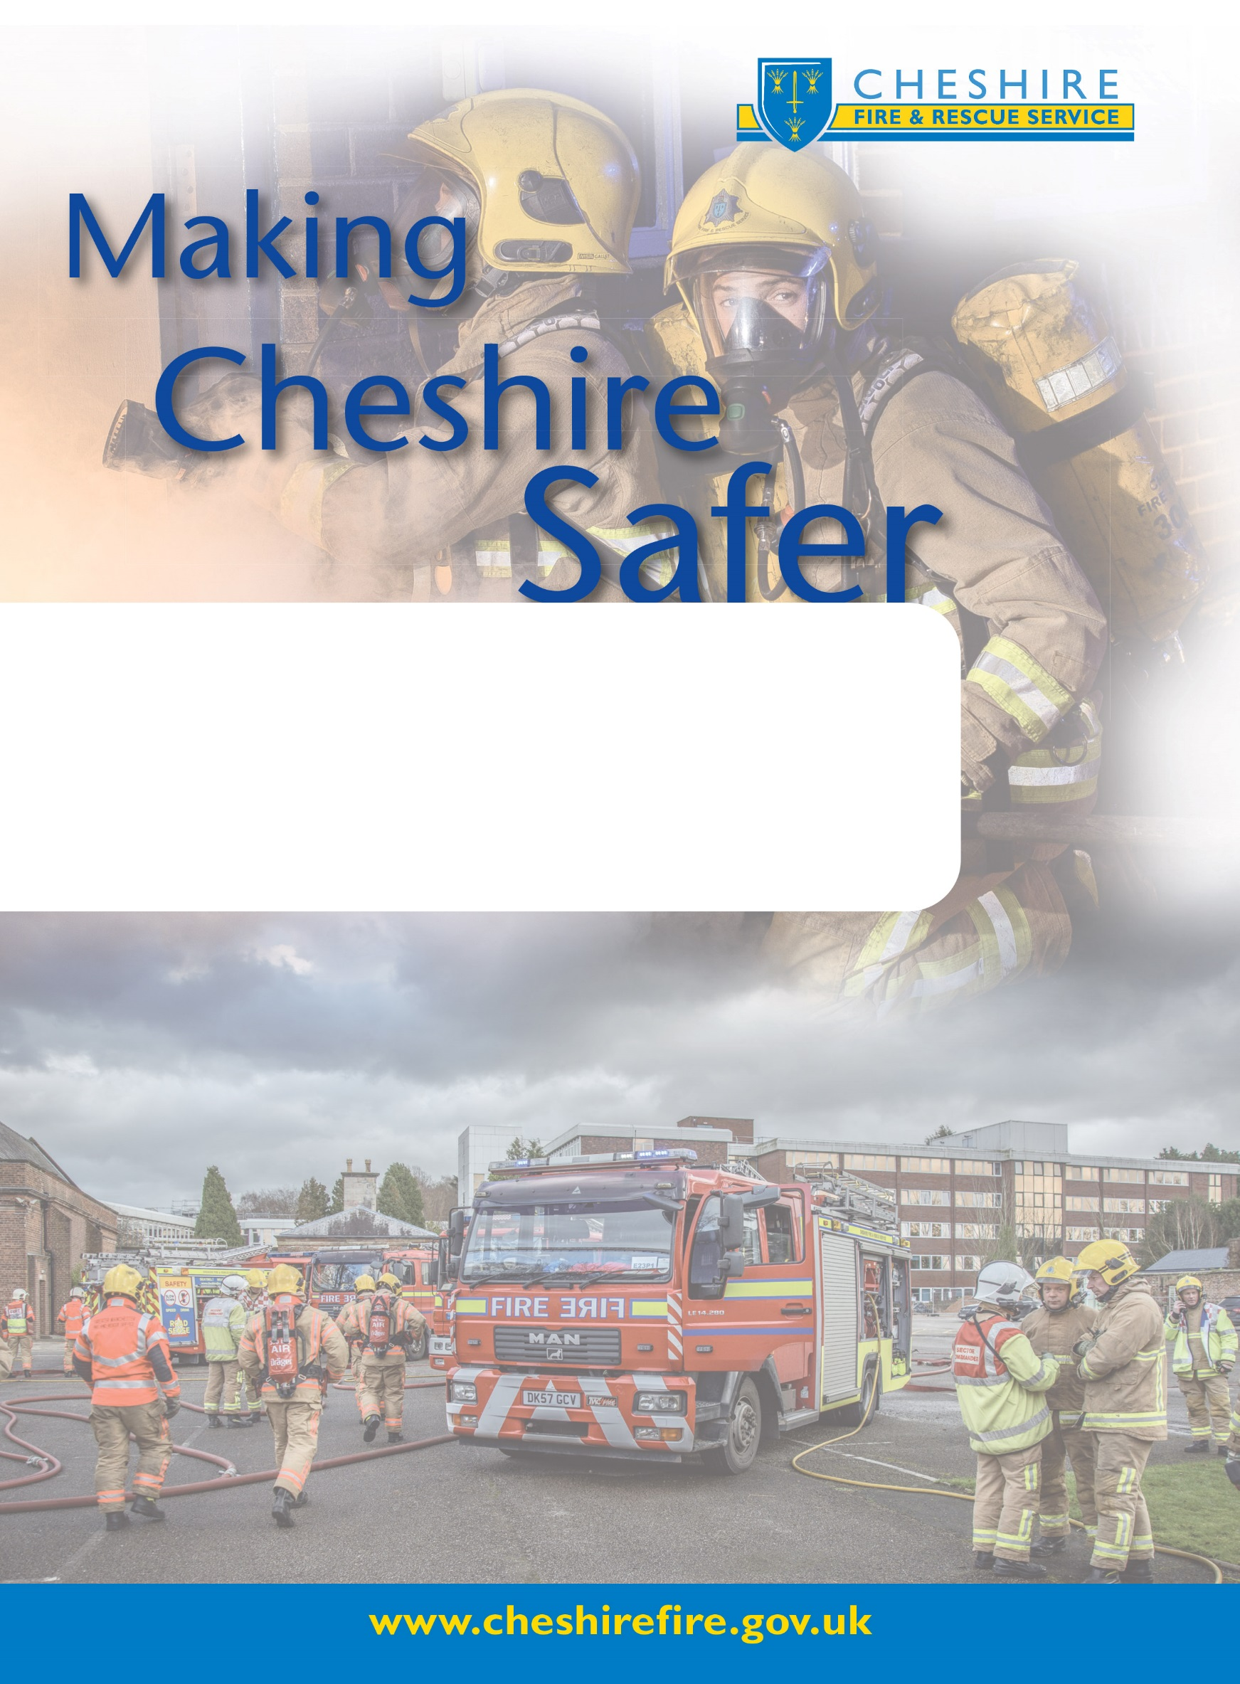
Cheshire Fire & Rescue Service
RISK MANAGEMENT POLICY
May 2021

CONTENTS

1 Introduction 3
2 What this Policy is about? 3
3 Joint Risk Management Approach 3
4 What is Risk Management? 3
5 Responsibilities/Governance 7
6 Related Documents and Links 9
7 Glossary 10
8 Policy Review 11

1 Introduction
The Risk Management function is part of the joint corporate services Planning and Performance team based at Clemonds Hey. Whilst Fire and Police are separate organisations each with their own risk appetite there is an opportunity to develop a more joined up and systematic approach to the identification, documentation and management of risk.
All Employees across Cheshire Fire and Rescue Service (CFRS) need to be aware of their responsibilities in relation to risk management and know the channels that are in place to escalate risks and who to contact.

2 What this Policy is about?
The Policy is an overarching document providing direction and signposting in relation to CFRS’ risk management approach. The application of an effective risk management policy will assist CFRS to:
- Achieve organisational objectives
- Enhance service delivery
- Identify and assess new opportunities to improve services
- Provide a systematic and coordinated approach to the management of risk
- Demonstrate good governance arrangements
A detailed risk management process for CFRS which underpins this policy can be accessed in Section 6, including the risk scoring matrix.

3 Joint Risk Management Approach
Planning and Performance Risk Officers (Joint Corporate Services) will:

- Schedule meetings with all Heads of Departments (HoDs) quarterly to proactively review risk registers and update actions/progress.
- Escalate risks to relevant fire boards and committees or the strategic risk register where tolerances are exceeded or reduced.
- Provide risk management expertise and relevant guidance to support the organisations in the management of risk.
- Maintain good quality and consistent risk registers.
- Act as gatekeepers of the risk management policy, procedures and framework ensuring regular reviews are undertaken to keep them relevant and aligned to current guidance and practice.

Risk Reporting

- Current local risk reporting and governance arrangements remain in place.

Risk Management Training

Training needs of all staff are assessed annually and the Planning, Performance & Risk Team in conjunction with HR determine what risk management training will be delivered in year; this is dependent on the local needs assessed as a requirement for the role.
There are three levels of risk management training offered:

- Essentials of Enterprise risk Management (2 day course) which is offered to Fire and Police staff - provided by Gallagher/Bassett RMP.
- In house risk management overview presentations – provided by Planning, Performance & Risk Team.
- Risk Champions Training – this training provides a complete overview of the basics of risk management at scheduled champion’s events to support the role.

Note More detailed procedures can be found in the Risk Management Practitioners Guide – See Section 6.

4 What is Risk Management?
Risk Management is the planned systematic approach in identifying, evaluating and assessing risks to achieve continuous improvement and taking decisions to mitigate and minimise the likelihood or impact of those risks in the achievement of organisational objectives.

Effective risk management can help;
- reduce the frequency and consequences of negative risks (threats), and
- maximise the frequency and benefits of positive risks, (opportunities)
The diagram below summarises how risk management is integral to the delivery of organisational strategy.

4.1 Strategic Influences
- The Fire Authority’s Four Year Integrated Risk Management Plan 2020 - 2024 (IRMP) and Annual Action Plans: which outlines the organisation strategy in delivering services and achieving objectives for the communities of Cheshire?
- Corporate and strategic planning process: risk identification forms a key part of the annual corporate planning processes through environmental and horizon scanning, HMICFRS inspection reports and the budget setting process.
- Transformation and Change: the organisation continues to be faced with a period of significant change in the context of national economic challenges and government policy. This will inevitably lead to changes in the way that CFRS provides services, manage staff, develops partnerships and engages with communities.
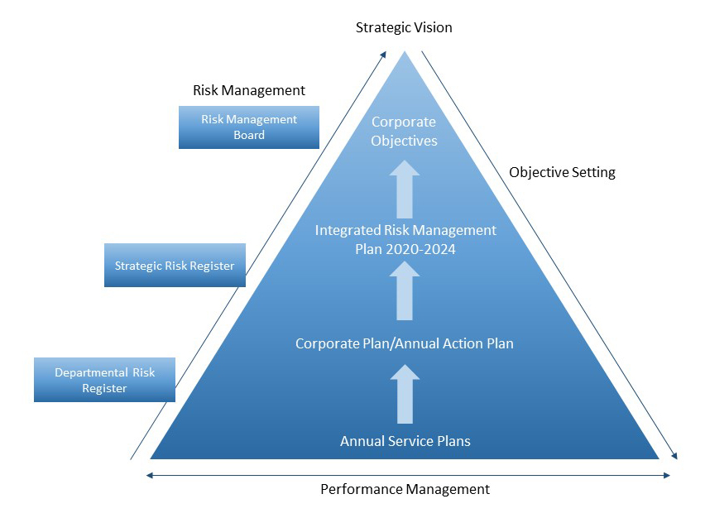

4.2 Vision
The focus for Cheshire Fire Authority, remains clear: to make Cheshire safer - this is articulated in the organisations Five Year Strategy and Annual Action Plan. – See Section 6.
4.3 Joint Decision Model (JDM) – Joint Emergency Services Interoperability Principles
One of the difficulties facing commanders from different responder agencies is how to bring together the available risk information, reconcile potentially differing priorities and then make effective decisions together.
To help all those involved in emergency response JESIP involves the use of a common model to help with a consistent and effective way of sharing incident information. The Joint Decision Model (JDM), shown below was developed to resolve this issue:
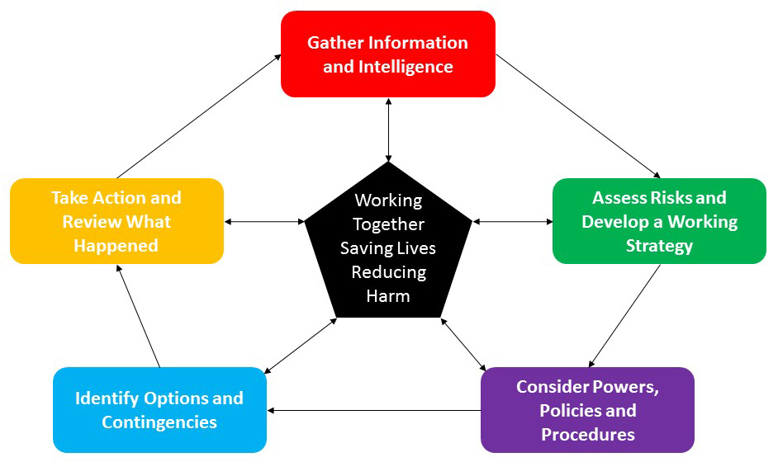

Decision making in the context of an emergency, including decisions on sharing information, does not remove the statutory obligations on CFRS. It is recognised that decisions will be made with an overriding priority of saving lives and reducing harm.
Select the link for more guidance in relation to the Joint Decision Making Model (JDM) http://www.jesip.org.uk/joint-decision-model.

4.4 Risk Appetite
CFRS’ business objectives are integral to its appetite for, and tolerance of risk. An organisation’s appetite for risk will impact upon its ability to achieve its objectives. Opportunities mat involve an organisation optimising risk taking and accepting calculated risk. The range of identified risks which the organisation is prepared to accept, tolerate or be exposed to is its risk appetite.
The risk appetite is based on priority with red risks scoring 15-25; amber risks scoring 9-14 and green risks below 8. All amber and red risks require a risk mitigation plan – See Section 6 for risk scoring and guidance:
15-25 | High
9-14 | Medium
1-8 | Low

5 Responsibilities/Governance
The table below sets out the governance responsibilities for Officers, Managers and Members:
RESPONSIBILITY | RISK GOVERNANCE
Fire Authority | Overall responsibility for risk management sits with the Fire Authority. The Fire Authority has appointed two Member Champions to sit on the Risk Management Board (RMB).
Chief Fire Officer and Chief Executive | The Chief Fire Officer and Chief Executive (Fire) Chairs the Risk Management Board and is responsible for ensuring that the Board promotes and supports the risk management policy and framework.
Risk Management Board (RMB) | RMB meets six monthly to consider issues around the approach to risk management, particularly in identifying, assessing and monitoring Corporate and Strategic risks and approving changes to risk profiles. The Board has a critical ‘check and challenge’ role to ensure that identified risks are based on sound risk information and are adequately evaluated. The Strategic risk registers are recorded and will be a key piece of information used to determine the Authority’s levels of balances and reserves, RMB also signs off the annual review of the Service Crisis Management Plan (CMP). The Risk Management Annual Report is received by the Board annually prior to being presented to Performance & Overview Committee.  The Risk Management Board comprises of:  - Chief Fire Officer and Chief Executive  - Deputy Chief Fire Officer  - Section 151 Officer  - Monitoring Officer (Director of Governance & Commissioning)  - Head of Finance (Joint Corporate Services)  - Planning, Performance and Risk Manager (Joint Corporate Services)  - Planning, Performance & Risk Officer (Joint Corporate Services)  - Internal Audit representative (MIAA)  - Two Member Champions from the Fire Authority
Heads of Department  (HoDs) | HoDs are responsible for ensuring that risk is managed effectively in each department and have responsibility for championing the culture of risk management. They should review departmental activities on a regular basis to identify, analyse and implement appropriate control measures. HoDs should escalate risks where a high degree of likelihood or impact is likely to significantly affect performance or organisational objectives.  Any risks that require escalation should be discussed with the Planning, Performance and Risk Officers in the first instance that will provide direction and guidance.
Joint Corporate Services  Planning, Performance and Risk Officers | The Planning, Performance and Risk Officers based at Clemonds Hey are the gatekeepers of the policy and framework . The team Lead and facilitate quarterly risk review meetings with every Head of Department (HoDs) and escalate and de -escalate key risks to the relevant boards, committees and groups when risk tolerances are either exceeded or reduced.
Risk Champions | Fire and Joint Corporate Services Teams - Identified managers/officers who take on a proactive ‘Champion’ role.
Managers and Officers | All Managers and Officers in Cheshire Fire & Rescue have a responsibility for risk management within their own specific areas of work: this includes operational, project and partnership risks. They are also responsible for supporting compliance with the policy.
Employees | Risk Management awareness is required across the organisation, to embed a risk management mind set and culture. Employees should be aware of the general principles of risk management; they should feel confident and able to raise risk issues with managers and officers.
Risk Owners | Risk Owners are the named individuals responsible for delivering the actions set out in risk registers and ensuring that information populated in their risk registers is relevant and fit for purpose.
Action Owners | Action Owners are responsible to the Risk Owner for the implementation of specific action(s) identified in the risk management plan.
Internal/External Audit | Provide independent assurance
Senior Information Risk Owner (SIRO) | The SIRO is the Senior Officer with responsibility for ensuring that the organisation meets appropriate information management standards and complies with data legislation, ensuring that appropriate policies, processes and guidance are in place to manage the organisation’s information risks.

6 Related Documents and Links
To access the risk management scoring matrix; detailed risk management procedures for Cheshire Fire and Rescue Service and organisational plans/strategies; see below:
ATTACHMENTS
Common Risk Management Scoring Matrix
PROCEDURES/GUIDELINES
Cheshire Fire & Rescue
practitioners guide
ORGANISATIONAL PLANS & STRATEGIES
Cheshire Fire and Rescue Service (CFRS) | Integrated Risk Management Plan (IRMP)

7 Glossary
This glossary is not exhaustive, but covers the terms used in this Policy and Practitioners guides.
Assurance | Independent confirmation that risk assessments and control responses are appropriate.
Compliance | Complying with laws and regulations applicable to an entity.
Controls | Actions in place to reduce the likelihood and or impact of risk.
Corporate Governance | Framework of accountability which organisations take decisions, lead and control their functions. Corporate governance includes management structures, risk management, reporting, audit, scrutiny and assurances.
Impact | The effect of a risk should it occur.
Liability | A legal responsibility for something, (e.g. responsibility to pay compensation).
Likelihood | The anticipated frequency with which a risk is expected to occur.
Opportunity | An uncertainty of event or set of events that, should it occur, will have a positive effect on the achievement of objectives.
Risk | The chance or something uncertain happening that will have an impact upon objectives, positive, (opportunity), or negative (threat).
Risk Appetite | The level of risks that organisations are prepared to accept in the delivery strategic objectives.
Risk Identification | The process of determining what can happen, why and how.
Risk Owner | The person assigned to manage the risk including monitoring the risk, its controls and any treatments.
Risk Register | Record containing details of identified risks, risk scores, controls put in place, risk owner and progress in managing the risks.
Risk Scoring | The process of assessing and quantifying the probable impact and likelihood this is done using a 5 x 5 matrix.
Risk Treatment | Action taken to mitigate the risk.
Risk Transfer | Assigning the responsibility to another party through legislation, contract, insurance or other means.
Risk Tolerance | The acceptable variation relative to the achievement of objectives.
Threat | Uncertainty event or set of events that, should it occur, will have a negative effect on the achievement of objectives.
Uncertainty | Inability to know in advance the exact likelihood of future events.

8 Policy Review
Policy will be reviewed every three years.

