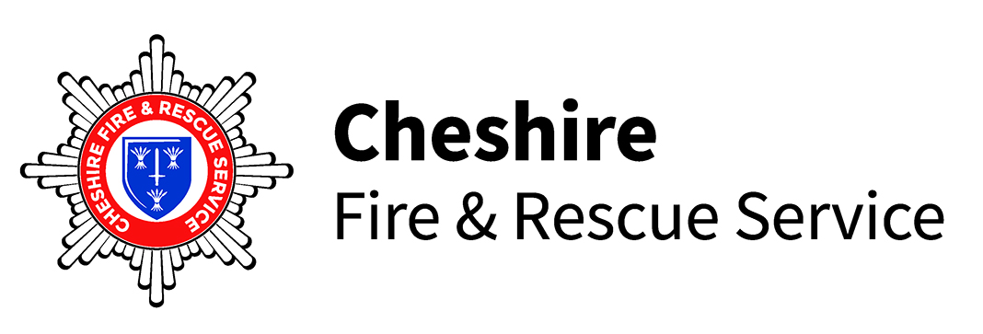
- General Information

Cheshire Fire and Rescue Service has a long and proud tradition for innovation and taking a lead on both the safety of the communities it serves and the people it employs. Our vision is ‘a Cheshire where there are no deaths, injuries or damage from fires and other emergencies.’ and our mission ‘is to help create safer communities, to rescue people and protect economic, environmental and community interests.’

The Service is led by the Chief Fire Officer Alex Waller and the Service Management Team and provides a 24 hour service to emergency incidents to just over 1 million people across the four unitary council areas of:

  - Halton
  - Warrington
  - Cheshire East
  - Cheshire West and Chester

The Service responds to all emergency calls from the public for assistance. Many emergency calls however are not to fires, but to incidents where members of the community are trapped in vehicles following road traffic collisions, trapped in machinery, or trapped in less life threatening circumstances, as well as being called to chemical spillages and toxic emissions. The Service is also required to deal with many other domestic situations, such as flooding, storm damage, people unable to gain access to premises, animals in distress etc. Currently, approximately 15,105 emergency calls are received each year, 2,665 of which relate to property fires, 7,288 to other incidents and 4,778 to false alarms, unfortunately including 374 malicious calls.

The Service has a comprehensive plan to improve response times across Cheshire, Halton and Warrington. The plan, which has involved the building of four new fire stations at Alsager, Lymm, Penketh and Powey Lane was the subject of a widespread public consultation. Additionally, the Service has built a state of the art safety and life skills centre adjoining the fire station at Lymm which delivers educational programmes targeted at schools, new parents and carers of older and vulnerable people.

Cheshire Fire & Rescue Service operates:

  - 28 Fire Stations
  - 3 Community Safety Centres
  - 3 Fire Protection Offices
  - A Headquarters, Training Centre and Workshops based at Sadler Road, Winsford
- A safety and life skills centre at Safety Central in Lymm.

The Service’s emergency call handling function is provided by North West Fire Control, based in Lingley Mere in Warrington. This is a collaboration between four fire and rescue services providing a control room function for Cheshire, Cumbria, Greater Manchester and Lancashire.

The Service also provides community safety advice, which helps to reduce risks and to improve community and public safety and business safety and safety at work.

Staff are employed in a variety of roles including operational fire-fighters, professional, specialist, technical, administrative and manual roles. As of 5th February 2025, the overall staff number within the Service are 838. The split between operational and support staff is 616 and 222, respectively.

There are a number of different operational shift patterns in existence across the Service including wholetime (12 hour shifts), nucleus crewing, (12 hour day shifts) day crewing, DC1 (12 hour day shifts, self rostering and 12 hours on-call at night), weekday crewing (09:30-18:00 Monday to Thursday, and 09:30-17:30 on Fridays) and on-call.

Cheshire Fire and Rescue Service is committed to ensuring all colleagues feel safe and able to be themselves in work, and that no one faces barriers that prevent them accessing our services or employment opportunities. This is reflected in our core value, to ‘be inclusive,’ and our ambitious and award-winning work towards equality, diversity and inclusion (EDI). We are a Top 50 Inclusive Company, a Disability Confident Employer and a White Ribbon organisation. We also have four vibrant staff inclusion networks for female colleagues, those who identify as LGBT+, staff from diverse ethnic backgrounds and those with neurodivergent conditions. For further information on our equality, diversity and inclusion activity, please visit: Cheshire Fire & Rescue Service - Equality and Diversity’

England’s independent fire and rescue service watchdog has praised Cheshire Fire and Rescue Service’s work to keep communities safe from fire and to create a fair and inclusive workplace. In its latest round of inspections His Majesty’s Inspectorate of Constabularies and Fire and Rescue Services (HMICFRS) rated the Service as ‘good’ across all three of its inspection criteria. This means it is ‘performing as expected’ in the way it prevents and responds to emergencies, spends its money and it looks after its people.

- The Post

A job description and person specification for the post are attached.

- Duties and Responsibilities

These are set out in the attached job description.

- Qualifications/Experience

These are set out in the attached person specification.

- Salary

Starting Salary of £40,467 per annum within the Salary Scale PM1 range £40,476 - £44,711 per annum based on experience.

- Additional Payments

This post does not attract any additional basic payments.

- Hours of Work

This is a full time post and the successful applicant will need to work flexibly.

- Pension Arrangements

The person appointed will be enrolled into the Local Government Pension Scheme (subject to the normal rules of eligibility).

Further information about the Local Government Pension Scheme will be supplied in any letter of appointment. Employees who are aged sixteen and over who do not choose one of the options above will be automatically placed in the scheme at a rate of 5.8%. This rate is subject to annual review.

- Notice to Terminate Employment

a) By the Employer

According to length of service as prescribed in Employment Legislation.

b) By the Employee

The minimum period you are required to give to terminate your employment is 2 calendar months.

- Annual Leave

The annual leave entitlement for this post is 26 days, plus 5 extra days for five years Local Government Service. In addition, eight Bank Holidays are granted annually.

- Probationary Period

All appointments are subject to a probationary period of 6 months.

- Smoking

All fire service premises are designated no-smoking areas.

- Alcohol, Drugs and Other Substance Misuse

All new employees to Cheshire Fire Authority will be required to comply with the Alcohol, Drugs and Other Substance Misuse policy and will be subject to appropriate screening as part of the pre-employment medical.

- Conflicts of Interest - Relatives and Relationships

The Service’s Code of Conduct for Employees requires all applicants for an appointment to disclose, before appointment, details of any relative or personal relationship to an elected member or employee of the Service. Deliberate non-disclosure will disqualify the applicant. No candidate will be rejected for appointment solely because of potential problems through a personal relationship, although the problems that may occur will be openly discussed.

For this purpose, a relative is a marital or extra-marital partner, parent/child, brother/sister, grandchild/grandparent, uncle-aunt/nephew-niece/cousin, in-law or equivalent "step" relationship.

If applicants do not give details of a relationship, they are liable to be disqualified from the job or if appointed, liable to be dismissed. This will also be the case if the applicant or someone else uses improper influence to attempt to get you the job (but this does not prevent a County Councillor or employee giving a written reference about you). It should also be noted that if an applicant is related to another Cheshire Fire Authority employee this may affect the location or type of job you could be offered.

- Politically Restricted Posts

The Local Government and Housing Act 1989 (as amended by the Local Democracy, Economic Development and Construction Act 2009) includes provisions to reinforce the political impartiality of certain local government employees and introduces the principles of "politically restricted post" (PoRP). Employees occupying such posts will not be permitted to stand for election or engage in the range of political activities specified in the Act and regulations.

- Employee Benefits

All employees of the Fire and Rescue Service are eligible to benefit from the Fire Fighters Charity. Details will be made available upon appointment and employees are encouraged to consider covenanting in order to ensure regular income to the fund.

- Asylum and Immigration Act 1996

All external successful applicants will be asked to confirm, in advance of taking up the appointment, that they are eligible to work in the United Kingdom. In order to establish this, the successful applicant will be asked to provide documentation showing their National Insurance number or provide copies of Tax Forms P45 or P60, or if this is not possible, other evidence of their entitlement to work.

- Equal Opportunities

Cheshire Fire and Rescue Service is proudly committed to equality, diversity and inclusion for all its staff and communities. Promoting equality and diversity is a Core Value at Cheshire Fire and Rescue Service and we are explicitly inclusive of all, regardless of gender, race, sexual orientation, gender identity, or disability. All applicants should note that they will be considered on the basis of suitability regardless of disability, gender, race, religion, age, sexual orientation and marital status or any other discrimination which is unfair or unreasonable.

- Data Protection Act 2018 (DPA)

In accordance with the Equality Act 2010, it is good practice to know the composition of people applying for roles within the Service so that we can build an accurate workforce picture. Through the application form we ask for your name so we can effectively manage the logistics for application, and the interview and assessment process thereafter (if your application is successful). Your name, or any identifiable information will not be shared with other organisations and will not be used for any other purpose. We ask for your help to develop an understanding of workforce diversity so we can monitor any potential barriers faced, however providing this information is voluntary.

The information you provide will be held by Cheshire Constabulary and Cheshire Fire and Rescue Service Joint Corporate Services for the purposes outlined above and in accordance with the Data Protection Act 2018 (DPA) and other associated data protection legislation as well as our and duties under the Equality Act 2010. We will use the information collected from you to report on the composition of applicants. Your information will be used to form statistics and reports that are high level and will not identify you or any other individual.

Your information will only be held in an identifiable form for as long as is necessary by the Service and in accordance with their retention schedule. You have certain rights under data protection legislation regarding your personal data, which includes the right to access data held about yourself, to ensure it is accurate and to ask it to be deleted or no longer processed. You also have the right to complain about the processing of your information if you are not happy about any aspect of the processing.

For more information about your rights and to contact our data protection officer, please see our full privacy notice on the Service website http://www.cheshirefire.gov.uk/about-us/key-documents/data-protection. You can also contact the Service via email, telephone or written letter.

- Convictions Policy

Cheshire Fire and Rescue Service acknowledge the importance of the rehabilitation of offender’s regime and has an open minded approach to the potential recruitment of people with previous convictions. The Service aims to promote equality of opportunity to ensure that people with criminal records applying for jobs should be treated according to their merits. Consideration will be given to any special criteria that applies to the role for example, those that involve caring for children or vulnerable adults which will debar some applicants.
The Service will seek disclosure of criminal convictions whenever it is handling job applications and this information will only be used to assess an applicant’s suitability for a job. The Service acts in accordance with the law and follows best practice. For some jobs applicants will be expected to disclose all convictions (even those that are spent). For other jobs only details of unspent convictions are sought. The Service will carry out enhanced Disclosure and Barring Service (DBS) checks for jobs which involve working with vulnerable adults and children. All other posts will be subject to a satisfactory Standard Disclosure & Barring Service check.

- Acknowledgement of Application

If you would like receipt of your application to be acknowledged, please enclose a stamped addressed envelope if posting or if emailing your application an auto email will be sent to you confirming receipt of your email to the recruitment inbox.

In view of the large number of applications normally received, the Fire Authority regrets that it is no longer possible to inform candidates individually of the result of their applications. It is expected that it will take six weeks after the closing date to fill the post for which you are an applicant. If you have not received a letter inviting you for interview within this period, you should assume that your application has not been successful.

- Closing Date

Midnight Sunday 8th June

- The Selection Process

All successful candidates will be asked to attend an interview.

- Interview Date

To be confirmed.

- Return of Application Forms

Completed application forms should be via email to recruitment@cheshirefire.gov.uk

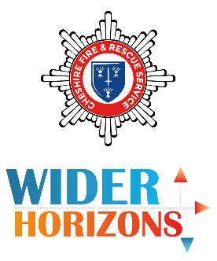
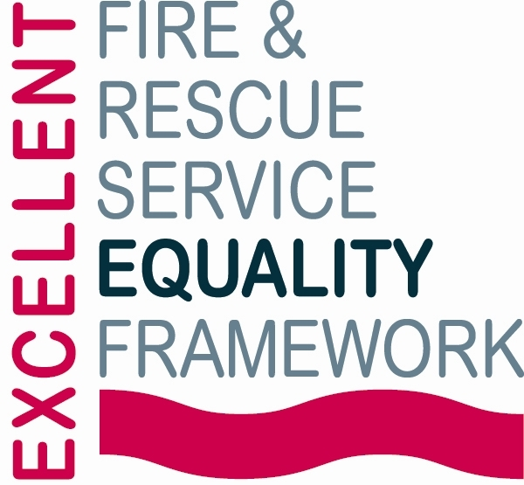 | 