

Station Manager Promotion Application
Please read the guidance that accompanies this document before completing.
It is essential that you use the TAB key to move from one field to the next, rather than pressing RETURN. If you wish to go back to a field, use SHIFT and TAB together or simply click in the field you wish to edit.

Section 1

Personal and Contact Details

First Name(s): | Last Name:
Station/Department: | Work Telephone:
Station/Department: | Mobile:
Work Email: | Personal Email:

Section 2

Eligibility for Promotion
Having read the promotion guidance document, please ensure that you fulfil all of the criteria to be eligible to apply for promotion before submitting your application. If you do not fulfil all of the requirements but believe you have extenuating circumstances that you wish to be considered, please complete the box below.
Rationale

In the last 12 months have you attended or are you booked to attend a promotion board development session (either application forms, interview skills or presentation skills):
Yes

If yes, please provide date/ name of session/s:

No

Other relevant training

Section 3

Qualifications, Relevant Job History and Training

Internal applicants do not need to complete this section

Relevant Qualifications – starting with the most recent
Educational/vocational qualifications | Dates of education | Grade (if applicable)
Relevant Job Training - starting with the most recent
Title | Date | Pass/Fail (if applicable)
Relevant Job History – starting with the most recent
Role | Employer | Dates

B

Section 4

Job Preferences and Location
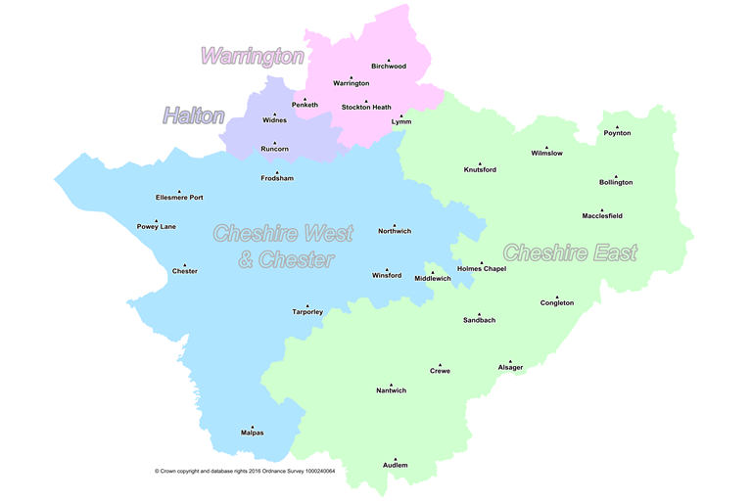
Please indicate if you have any preference in respect of location(s)
I have no preference
I have a preference as indicated below:

Preference | Department
Preference 1 | Choose an item.
Preference 2 | Choose an item.
Preference 3 | Choose an item.

Please note, OTL and Prevention positions are based in Winsford. Protection positions are based in Winsford, Chester, Warrington and Crewe.

Preference | Location
Preference 1 | Choose an item.
Preference 2 | Choose an item.
Preference 3 | Choose an item.

Section 5
Personal Statement
In this section you are asked to provide a personal statement to support your application and highlight your suitability, readiness and motivation for seeking promotion or transfer into the role of Station Manager.
This statement is a marked criteria and if successful, will be considered when assessing your suitability for specific roles.
Please do not exceed a maximum of 800 words.

Section 6

Assessment of Potential
In this section you should refer to the NFCC Leadership Framework before formulating your responses to the questions below.

Unless you are already substantive and applying to transfer in, it is not expected that you will be currently performing at the level of Station Manager. The evidence that you provide however, will be evaluated to help identify your suitability to be promoted into the role.

A maximum of 250 words should be used for each answer. Please insert the total word count at the end of each question.

Q1. Please give one example that demonstrates your competence in the
area of Personal Impact
# Words
Q2. Please give one example that demonstrates your competence in the
area of Outstanding Leadership

# Words

Q3. Please give one example that demonstrates your competence in the
area of Service Delivery
# Words
Q4. Please give one example that demonstrates your competence in the
area of Organisational Effectiveness
# Words

Section 7

Line Manager Endorsement

Management endorsement reflects a judgement of the candidate’s readiness for promotion and honesty of evidence provided, not an evaluation of the standard or quality of the application submitted.

I have reviewed the evidence and based on this I

Endorse the application Do not endorse the application

Last Appraisal Rating
Please provide your rationale for either endorsing or not endorsing this application.

Comments should include reference to the following 4 leadership areas;
Personal Impact; Outstanding Leadership; Service Delivery; Organisational Effectiveness.

Details of Officer completing Section 7
Name:

Job Title:

Contact
Telephone Number:

Section 8

Grandparent Manager Endorsement

Management endorsement reflects a judgement of the candidate’s readiness for promotion, not an evaluation of the standard or quality of the application submitted

Decision of Grandparent Manager
I endorse this application: Yes No

Name:

Job Title:

Department:

Contact
Telephone Number: Date

Please provide your rationale for either endorsing or not endorsing this application.

Section 9

Declaration of Availability

If you are shortlisted following submission of your application, you will be invited to the next steps which will take place on the dates outlined below.

We would ask that all shortlisted candidates make every effort to be available to participate in the process on the assigned dates. For planning purposes please declare your availability below.

Stage 2 – Incident Command Assessment  Morning and Afternoon | AM | PM
Friday 1st May
Tuesday 5th May
Wednesday 6th May
Thursday 7th May
Friday 8th May
Stage 2 – Written (In-tray) Exercise  Morning and Afternoon | AM | PM
Monday 18th May
Tuesday 19th May
Wednesday 20th May

Stage 3 – Interview and Presentation

If you are successful at Stage 2, you will be invited to Stage 3 of the process which will comprise of an interview with presentation.

We appreciate that availability may change but please indicate as many days as possible so that we can facilitate applicants and panels.

Please confirm your availability to attend on any of the following dates should you be invited to participate in Stage 3 of the selection process.

Stage 3 – Interview / Presentation | AM | PM
Monday 1st June
Tuesday 2nd June
Wednesday 3rd June
Thursday 4th June
Friday 5th June

The outcome of your interview will be communicated to you by the 10th June.

Interview feedback sessions will be made available to all candidates whether successful or unsuccessful across weeks commencing 15th & 22nd June (TBC)

Submission of applications 17:00 hours 14th April 2026

Please email your completed form to recruitment@cheshirefire.gov.uk

Note: Any applications received after the closing date will not be considered.

Please note it is the responsibility of the applicant to plan accordingly and ensure that the form is submitted on time with all the necessary management endorsement sections completed. Incomplete applications will not be considered within the selection process.

