

**Station Manager Promotion Application**

**Please read the guidance that accompanies this document before completing.**

**It is essential that you use the TAB key to move from one field to the next, rather than pressing RETURN. If you wish to go back to a field, use SHIFT and TAB together or simply click in the field you wish to edit.**

**Section 1**

**Personal and Contact Details**

|  |  |
| --- | --- |
| First Name(s): | Last Name: |
| Station/Department: | Work Telephone: |
| Mobile: |
| Work Email: | Personal Email: |

**Section 2**

**Eligibility for Promotion**

Having read the promotion guidance document, please ensure that you fulfil all of the criteria to be eligible to apply for promotion before submitting your application. If you do not fulfil all of the requirements but believe you have extenuating circumstances that you wish to be considered, please complete the box below.

|  |
| --- |
| **Rationale** |
|  |

**Section 3**

**Section 3**

**Qualifications, Relevant Job History and Training**

**Internal applicants do not need to complete this section**

|  |  |  |
| --- | --- | --- |
| **Relevant Qualifications – starting with the most recent** | | |
| **Educational/vocational qualifications** | **Dates of education** | **Grade (if applicable)** |
|  |  |  |
| **Relevant Job Training - starting with the most recent** | | |
| **Title** | **Date** | **Pass/Fail (if applicable)** |
|  |  |  |
| **Relevant Job History – starting with the most recent** | | |
| **Role** | **Employer** | **Dates** |
|  |  |  |

**B**

**Section 4**

**Job Preferences and Location**

|  |
| --- |
| **Please indicate if you have any preference in respect of location(s)** |
| I have no preference  I have a preference as indicted below:   |  |  | | --- | --- | | **Preference** | **Department** | | Preference 1 | Choose an item. | | Preference 2 | Choose an item. | | Preference 3 | Choose an item. |   Please note, OATT and Prevention positions are based in Winsford. Protection positions are based in Winsford, Chester, Warrington and Crewe.   |  |  | | --- | --- | | **Preference** | **Location** | | Preference 1 | Choose an item. | | Preference 2 | Choose an item. | | Preference 3 | Choose an item. | |

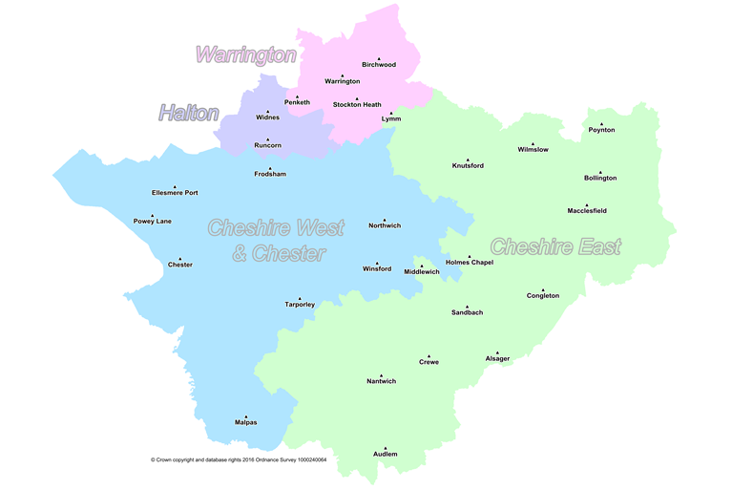

|  |
| --- |
| **Section 5**  **Personal Statement** |
| In this section you are asked to provide a personal statement to support your application and highlight your **suitability, readiness and** **motivation for seeking promotion or transfer** into the role of Station Manager.  If successful, this statement will be considered when assessing your suitability for specific roles.  Please do not exceed a **maximum of 800 words**. |
|  |

Internal candidates who were successful in reaching Stage 3 of the last promotion board process do not need to complete Section 6 of this form.

**Section 6**

**Assessment of Potential**

In this section it is suggested that you refer to the NFCC Leadership Framework before formulating your responses to the questions below.

Unless you are already substantive and applying to transfer in, it is not expected that you will be currently performing at the level of Station Manager. The evidence that you provide however, will be evaluated to help identify your suitability to be promoted into the role.

**A maximum of 250 words** should be used for each answer. Please insert the total word count at the end of each question.

|  |
| --- |
| **Q1. Please give one example that demonstrates your competence in the  area of Personal Impact** |
|  |
| **# Words** |
| |  | | --- | | **Q2. Please give one example that demonstrates your competence in the  area of Outstanding Leadership** | |
|  |
| **# Words** |

|  |
| --- |
| **Q3. Please give one example that demonstrates your competence in the  area of Service Delivery** |
|  |
| **# Words** |
| **Q4. Please give one example that demonstrates your competence in the  area of Organisational Effectiveness** |
|  |
| **# Words** |

**Section 7**

**Line Manager Support**

|  |
| --- |
| I have reviewed the evidence and based on this I  **Support the application Do not support the application** |
| **Last Appraisal Rating** |
|  |
| Please provide your rationale for either supporting or not supporting this application.  Comments should include reference to the following 4 leadership areas; **Personal Impact; Outstanding Leadership; Service Delivery; Organisational Effectiveness.** |

|  |
| --- |
| **Details of Officer completing Section 7** |
| Name:  Job Title:  Contact  Telephone Number: |

**Section 8**

**Grandparent Manager Endorsement**

|  |
| --- |
| **Decision of Grandparent Manager** |
| I endorse this application for promotion to Station Manager Yes  No  Name:  Job Title:  Department:  Contact  Telephone Number:       Date |

|  |
| --- |
| Please provide your rationale for either supporting or not supporting this application. |

**Section 9**

**Declaration of Availability**

If you are shortlisted following submission of your application, you will be invited to the next steps which will take place on the dates outlined below.

We would ask that all shortlisted candidates make every effort to be available to participate in the process on the assigned dates. For planning purposes please declare your availability below.

|  |  |  |
| --- | --- | --- |
| **Stage 2 – Incident Command Assessment**  Morning and Afternoon | **AM** | **PM** |
| 16th September 2025 |  |  |
| 23rd September 2025 |  |  |
| 25th September 2025 |  |  |
| 30th September 2025 |  |  |
|  |  |  |
| **Stage 2 – Written & Group exercises**  Morning and Afternoon | **AM** | **PM** |
| 7th October 2025 |  |  |
| 8th October 2025 |  |  |
| 9th October 2025 |  |  |

**Stage 3 – Interview and Presentation**

If you are successful at Stage 2, you will be invited to Stage 3 of the process which will comprise of a group exercise and interview with presentation.

We appreciate that availability may change but please indicate as many days as possible so that we can facilitate applicants and panels.

Please confirm your availability to attend on any of the following dates should you be invited to participate in Stage 3 of the selection process.

|  |  |  |
| --- | --- | --- |
| **Stage 3 – Interview / Presentation** | **AM** | **PM** |
| 21st October 2025 |  |  |
| 22nd October 2025 |  |  |
| 23rd October 2025 |  |  |
| 24th October 2025 |  |  |

**Submission of applications 17:00 hours 11th September 2025**

Please email your completed form to [recruitment@cheshirefire.gov.uk](mailto:recruitment@cheshirefire.gov.uk) by

**Note**: Any applications received after the closing date will not be considered.

***Please note it is the responsibility of the applicant to plan accordingly and ensure that the form is submitted on time with all the necessary management endorsement sections completed. Incomplete applications will not be considered within the selection process.***