
CONFIDENTIAL
Please read this form carefully before completing

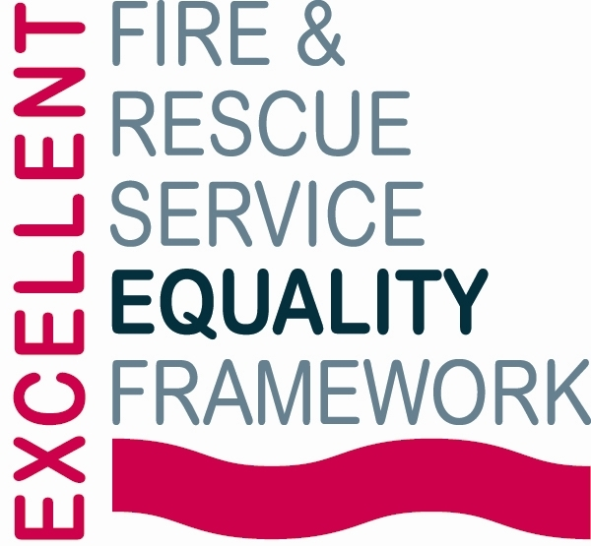 |  | 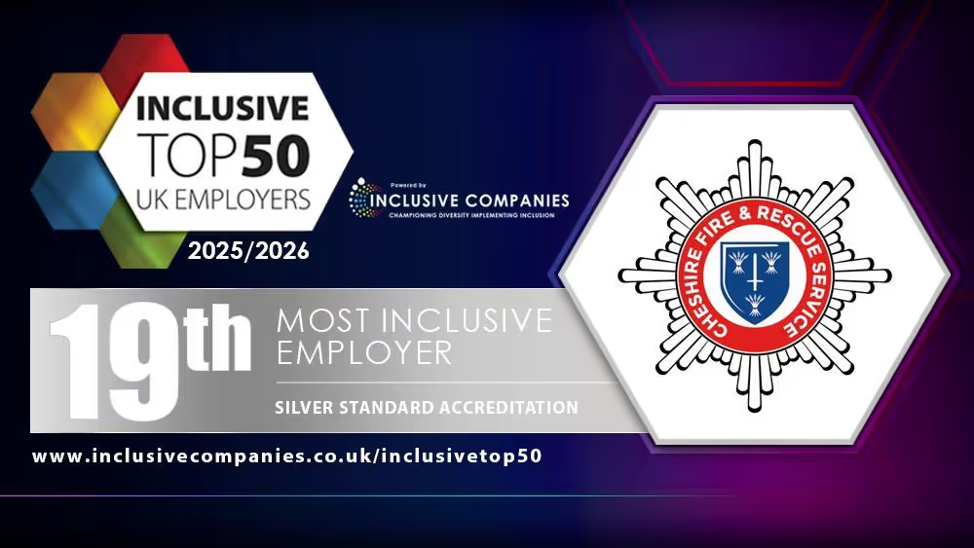

Application Form for Work Experience with Cheshire Fire and Rescue Service

Please ensure all sections of this form are fully completed, incomplete forms will not be processed
The outside pages of this application (which contain all your personal details and the equality monitoring information) will be detached and retained in HR.
Equality Act 2010
In accordance with the Equality Act 2010 and the Service’s Core Values, we are committed to creating an inclusive and accessible recruitment process for all candidates. If you require any reasonable adjustments to the recruitment process to enable you to fully demonstrate your skills and experience please notify apprenticeships@cheshirefire.gov.uk at the earliest opportunity so that reasonable measures can be implemented in good time. Please be reassured that disclosing the need for an adjustment will not negatively impact your application in any way.
Data Protection Act 2018 (DPA)
Information from this form will be processed in accordance with the Data Protection Act 2018, the UK’s implementation of the General Data Protection Regulation (GDPR). In signing it you agree to this data being held and processed.

Work Experience Programme Information:
For students living in, or attending schools/colleges in, Cheshire, Halton, and Warrington. Students will gain insight into fire service work, including education, community engagement, and operational training. The programme offers 12 places. Applications will be assessed using the information provided in the supporting information section, together with the declaration endorsements. Applicants may also be invited to attend an interview as part of the selection process.

Programme Dates: Monday 5th – Friday 9th July 2027

Locations: CFRS Headquarters, Winsford, CW7 2FQ & Safety Central, Lymm, WA13 0TE (other sites across Cheshire may also be visited). Students must be able to travel independently to all programme locations.
Timelines:
- Closing date for applications: Friday 18th December 2026, at 12:00 noon
- Applicants selected for interview to be notified: Monday 18th January 2027
- Interviews will take place: Tuesday 16th & Wednesday 17th February 2027
- Final outcomes communicated: By Monday 1st March 2027
Personal Details
Please type or write clearly
Mr/Miss/Mx | Pronouns: she/her he/him they/them other prefer not to say
First Name(s): |  | Known As: |  |  | Surname:
Date of Birth: |  |  |  | Age: 14-15 16-17
Address:
Post Code:
Student Telephone Number: |  |  | Student Email Address: (please write clearly)
Parent/Guardian Telephone Number |  |  | Parent/Guardian Email Address (please write clearly)
School / College Details
Name of School / College Attending:
Telephone Number: |  |  | E-mail Address: (please write clearly)
Are you available for the dates of the programme? Yes No
Additional Information:
Dietary Requirements/allergies: | Yes No (If yes, please provide details)
Personal Protective equipment (PPE) will be provided by CFRS where required.  Please provide your sizes: | Boots: (½ sizes available) Size:
 | Over-trousers: (please tick) Small Medium Large Ex Large
 | Jacket: (please tick)
 | Regular:  Small Medium Large Ex Large | Long:  Small Medium Large Ex Large
 | Height cm | Waist Size: cm
 | *CFRS Cadets only* I have my own PPE Yes No

Supporting information
This section must be completed. Applications will be assessed against the quality of responses provided below.
- Why do you want to do work experience with Cheshire Fire and Rescue Service?
Tell us why this placement interests you, what you hope to learn, and what this opportunity would mean to you personally. Please provide detailed examples to support your answer and explain how the experience may help you in your future education, career or personal development. (Maximum 300 words).

- Tell us about your activities, interests and achievements.

This could include activities at school or outside school, such as clubs, hobbies, sport, volunteering, work experience, caring responsibilities, community involvement, leadership opportunities, projects, or anything else you are involved in. Please tell us what you have learned from these experiences, the skills you have developed, and how these skills could support you during your work experience placement. Please provide detailed examples to support your answer. (Maximum 300 words).

- What achievement are you most proud of and why?

This achievement does not need to be academic. It could relate to school, sport, a hobby, volunteering, family responsibilities, or overcoming a personal challenge. Tell us why it is important to you and what it says about you as a person. (Maximum 300 words).

DECLARATION FORM

This form requires both parent/guardian and teacher endorsement to be processed
Student Declaration
I declare that the information given in this application is to the best of my knowledge correct.
Student Signature:
Parent / Guardian Declaration
I confirm the information is correct and accept responsibility for the student’s transport.
Parent/Guardian Signature:
If emailed, your printed name signifies acceptance of this declaration
Teachers / Tutors Comments
Applications without the required endorsement may not be considered.
The student is suitable for a CFRS placement |  | Agree Disagree
The student is authorised to attend |  | Agree Disagree
If you agree to the above statements, please provide additional information in support of this student’s application. (Approx 100 words)

I have read the student’s submitted evidence Yes No
Teacher / Tutor Signature:
Cadet Leaders Comments (for Cheshire Fire & Rescue Service Cadets only)
The student is suitable for a CFRS placement |  | Agree Disagree
Please provide additional information in support of this student’s application. (Approx 100 words)

I have read the student’s submitted evidence Yes No
Cadet Leader Signature:

EQUALITY MONITORING FORM

Cheshire Fire and Rescue Service is committed to ensuring all colleagues feel safe and able to be themselves in work. This is reflected in our core value, to ‘be inclusive’, and our ambitious and award-winning work towards equality, diversity and inclusion (EDI). We are a Top 50 Inclusive Company and a Disability Confident Employer. For further information on our equality, diversity and inclusion activity, please visit Cheshire Fire & Rescue Service - Equality and Diversity
If you are happy to provide us with the following information, it will help us to make sure that our recruitment process is as inclusive as possible and will assist with our commitment to diversity. This section is optional and will not form part of the selection process. Responses will be kept strictly confidential.
Double-click the box and select ‘Checked’ to indicate your response to each statement below.
Sex assigned at birth: Female Male Prefer not to say

Religion or Belief:
Buddhist  Christian  Hindu  Jewish  Muslim | Sikh  Spiritual but not religious  Other (please specify)  No religion  Prefer not to say

Ethnicity - I would describe my ethnic origin as:
White
A - English/Welsh/Scottish/Northern Irish/British  B - Irish  C - Gypsy or Irish Traveller | D - Roma  E - Any other White Background
Mixed or multiple ethnic groups
F - White and Black Caribbean  G - White and Black African | H - White and Asian  I - Any other Mixed or Multiple background
Asian or Asian British
J - Indian  K - Pakistani | L - Bangladeshi  M - Chinese  N - Any other Asian background
Black, Black British. Caribbean or African
O - Caribbean  P - African | Q - Black British  R - Any other Black background
Other Ethnic Group
R - Arab  S - Other Ethnic Group | Prefer not to say
Other (please provide details)

Equality Act 2010
In accordance with the Equality Act 2010 we are asking the question at the bottom of this page to ensure that all applicants who are disabled receive the appropriate support and reasonable adjustments and to monitor all aspects of our recruitment process.

Below are the four parts to the definition of someone who is classed as disabled under the Act.

- A disabled person is someone who has a physical or mental impairment.
Physical impairment includes hearing and visual impairments and conditions such as diabetes, dyslexia, severe disfigurement, heart conditions and epilepsy. Some conditions which may develop over time (specifically cancer, HIV or AIDS, or multiple sclerosis) will automatically be classed as disability from the day they are diagnosed.

Mental impairment Mental impairment includes learning disabilities and mental illnesses, such as autism, depression or PTSD.

People whose impairments are controlled, corrected or adjusted by medication or aids are covered by the Equality Act 2010 as are those who have had a disability in the past but have since recovered.

- The impairment has got to last, or be expected to last, at least 12 months.
- a person with a broken leg who is only temporarily disabled would not be covered.
- a person who has had an impairment, which may happen again, is covered.

- The impairment must have a substantial and long term adverse effect. This may be obvious in the time it takes someone to carry out a task or in the way he/she carries out the task.

- The impairment must affect the person’s ability to carry out normal day-to-day activities. These include mobility; manual dexterity; physical co-ordination; continence; ability to lift or carry objects; speech, hearing or sight; memory or ability to concentrate, learn or understand.

Do you consider yourself to be disabled as defined above? Yes No

If yes, please provide further information:

How did you hear about the Cheshire Fire and Rescue Service work experience programme? (Please tick one box)
Current Fire Service employee / elected member
Through my CFRS Cadet Leader
Fire Service website
My High School / Academy / College
Friends or family
I contacted CFRS directly
Other (please specify)

Relationship to Elected Members or Employees
Are you related to any elected member, or an employee of Cheshire Fire Authority? If so, please give their name and relationship.
Cheshire Fire & Rescue Service is committed to equality of opportunity.

All applications will be considered on their merits, and selection will be made solely on the basis of the suitability of applicants when assessed against job related criteria.

Please return the completed application form to: Apprenticeships@cheshirefire.gov.uk

