
CONFIDENTIAL
Please read this form carefully before completing

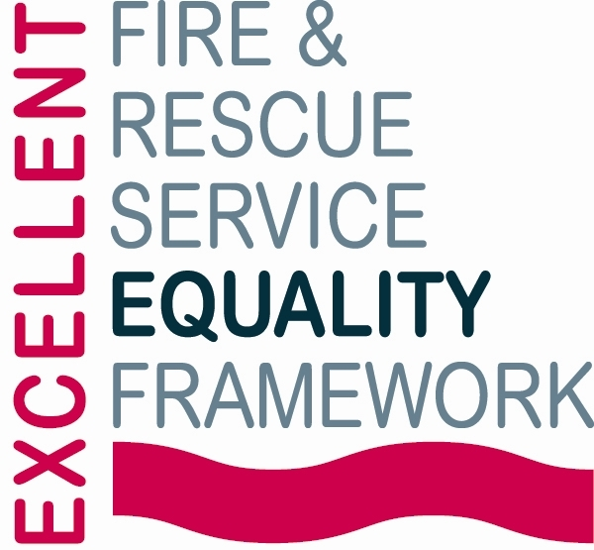 |  | 

Application Form for Work Experience with Cheshire Fire and Rescue Service

Please ensure all sections of this form are fully completed, incomplete forms will not be processed
The outside pages of this application (which contain all your personal details and the equality monitoring information) will be detached and retained in HR.
Equality Act 2010
In accordance with the Equality Act 2010 and the Service’s Core Values, we are committed to creating an inclusive and accessible recruitment process for all candidates. If you require any reasonable adjustments to the recruitment process to enable you to fully demonstrate your skills and experience please notify recruitment@cheshirefire.gov.uk at the earliest opportunity so that reasonable measures can be can be implemented in good time. Please be reassured that disclosing the need for an adjustment will not negatively impact your application in any way.
Data Protection Act 2018 (DPA)
Information from this form will be processed in accordance with the Data Protection Act 2018, the UK’s implementation of the General Data Protection Regulation (GDPR). In signing it you agree to this data being held and processed.

Work Experience – Cheshire Fire & Rescue Service
Cheshire Fire and Rescue Service (CFRS) is offering work experience to students living in, or attending schools/colleges in, Cheshire, Halton, and Warrington. Students will gain insight into fire service work, including education, community engagement, and operational training.

Dates: Monday 6th – Friday 10th July 2026
Locations: CFRS Headquarters, Winsford, CW7 2FQ & Safety Central, Lymm, WA13 0TE (other sites across Cheshire may also be visited). Students are responsible for their own travel.

The programme offers 12 places, and while we welcome all applications, we are only able to accommodate a limited number of students.
Timelines
- Closing date for applications: Friday 30th January 2026 at 12:00pm
- Successful applicants will be notified: Monday 9th February 2026
- Interviews will take place: Tues 17th, Wed 18th and Mon 23rd February 2026
Personal Details (please type or write clearly, where there is a box double-click to indicate your response)
Mr/Miss/Mx | First Name(s): |  |  | Known As:
Surname:
Date of Birth: |  |  | Age: 14-15 16-17
Address:
Post Code:
Student Telephone Number: |  | Student Email Address: (please write clearly)
Parent/Guardian Telephone Number |  | Parent/Guardian Email Address (please write clearly)
School / College Details
Name of School / College Attending:
Telephone Number: |  | E-mail Address: (please write clearly)
Are you available for the dates of the programme? Yes No
Additional Information:
Dietary Requirements/allergies: | Yes No (If yes, please provide details)
Personal Protective equipment (PPE):  Please provide your sizes | Boots (½ sizes available) Size:
 | Over-trousers (please tick) Small Medium Large Extra Large
 | Jacket (please tick)
 | Regular  Small Medium Large Ex Large | Long  Small Medium Large Ex Large
 | Height cm | Waist Size: cm
 | *CFRS Cadets only* I have my own PPE Yes No

Supporting Information – this section must be completed
- Why do you want to do work experience with Cheshire Fire and Rescue Service?
Tell us why this placement interests you and what you hope to learn. Please answer the question in detail to support your evidence. (Maximum 300 words)

- What are your activities and interests?
Share your clubs, hobbies, volunteering, work experience, or anything you enjoy outside school. Please answer the question in detail to support your evidence. (Maximum 300 words)

- What skills have you gained from your activities and interests, and how could you use them during your work experience? Please answer the question in detail to support your evidence. (Maximum 300 words)

DECLARATION FORM

This form requires both parent/guardian and teacher endorsement to be processed
Student Declaration
I declare that the information given in this application is to the best of my knowledge correct
Student Signature:
Parent / Guardian Declaration
I confirm the information is correct and accept responsibility for the student’s transport
Parent/Guardian Signature:
If emailed, your printed name signifies acceptance of this declaration
Teachers / Tutors Comments
The student is suitable for a CFRS placement |  | Agree Disagree
The student is authorised to attend |  | Agree Disagree
If you agree to the above statements, please provide additional information in support of this student’s application. (Approx 100 words)

I confirm I have read the student’s submitted evidence
Teacher / Tutor Signature:
Cadet Leaders Comments (for Cheshire Fire & Rescue Service Cadets only)
The student is suitable for a CFRS placement |  | Agree Disagree
Please provide additional information in support of this student’s application. (Approx 100 words)

Cadet Leaders Signature:

EQUALITY MONITORING FORM

Cheshire Fire and Rescue Service is proudly committed to equality, diversity and inclusion for all its staff and communities. Promoting equality and diversity is a Core Value at Cheshire Fire and Rescue Service and we are explicitly inclusive of all.
If you are happy to provide us with the following information, it will help us to make sure that our recruitment process is as inclusive as possible and will assist with our commitment to diversity. Completion of this form is optional, and your responses will be kept strictly confidential. For more information on why we collect equality monitoring data, please visit: Cheshire Fire & Rescue Service - Equality and Diversity
I am: Female Male Prefer to Self Describe:
My preferred pronouns are: she, her, hers he, him, his they, them, theirs

Nationality
Are you a UK citizen? Yes No

Are you an EU citizen? Yes No

If “yes”, from which country:

Religious Belief/Faith
Are you:
Buddhist  Christian  Hindu  Jewish  Muslim | Sikh  Other  None  Prefer not to say

Ethnicity - I would describe my ethnic origin as:
White
A - English/Welsh/Scottish/Northern Irish/British  B - Irish  C - Gypsy or Irish Traveller | D - Roma  E - Any other White Background
Mixed or multiple ethnic groups
F - White and Black Caribbean  G - White and Black African | H - White and Asian  I - Any other mixed background / Multiple background
Asian or Asian British
J - Indian  K - Pakistani | L - Bangladeshi  M - Chinese  N - Any other Asian background
Black or Black British
O - Caribbean  P - African | Q - Any other Black/ African/ Caribbean/ Black British background
Other Ethnic Group
R - Arab  S - Other Ethnic Group | T - Not known  Prefer not to say
Other (please provide details)

Equality Act 2010
In accordance with the Equality Act 2010 we are asking the question at the bottom of this page to ensure that all applicants who are disabled receive the appropriate support and reasonable adjustments and to monitor all aspects of our recruitment process.

Below are the four parts to the definition of someone who is classed as disabled under the Act.

- A disabled person is someone who has a physical or mental impairment.
Physical impairment includes hearing and visual impairments and conditions such as diabetes, dyslexia, severe disfigurement, heart conditions and epilepsy. Some conditions which may develop over time (specifically cancer, HIV or AIDS, or multiple sclerosis) will automatically be classed as disability from the day they are diagnosed.

Mental impairment Mental impairment includes learning disabilities and mental illnesses, such as autism, depression or PTSD.

People whose impairments are controlled, corrected or adjusted by medication or aids are covered by the Equality Act 2010 as are those who have had a disability in the past but have since recovered.

- The impairment has got to last, or be expected to last, at least 12 months.
- a person with a broken leg who is only temporarily disabled would not be covered.
- a person who has had an impairment, which may happen again, is covered.

- The impairment must have a substantial and long term adverse effect. This may be obvious in the time it takes someone to carry out a task or in the way he/she carries out the task.

- The impairment must affect the person’s ability to carry out normal day-to-day activities. These include mobility; manual dexterity; physical co-ordination; continence; ability to lift or carry objects; speech, hearing or sight; memory or ability to concentrate, learn or understand.

Do you consider yourself to be disabled as defined above? Yes No

If yes, please provide further information:

How did you hear about the Cheshire Fire and Rescue Service work experience programme? (Please tick one box)
Current Fire Service employee / elected member
Through my CFRS Cadet Leader
Fire Service website
My High School / Academy / College
Friends or family
I contacted CFRS directly
Other (please specify)

Relationship to Elected Members or Employees
Are you related to any elected member, or an employee of Cheshire Fire Authority? If so, please give their name and relationship.

Cheshire Fire & Rescue Service is committed to equality of opportunity.

All applications will be considered on their merits, and selection will be made solely on the basis of the suitability of applicants when assessed against job related criteria.

Please return the completed application form to: Apprenticeships@cheshirefire.gov.uk

