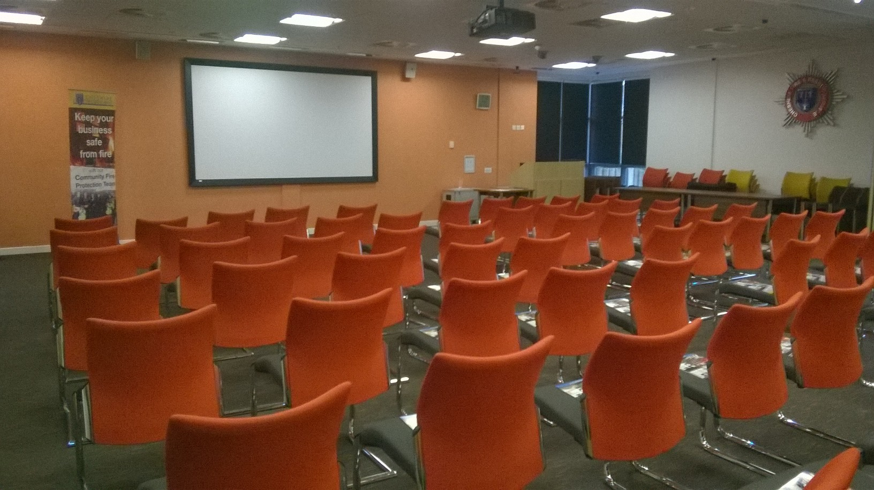
Calculating Occupancy Figures

This booklet has been produced to provide licensed premises with guidance and advice when calculating occupancy figures.

By following our guidance you could improve the fire safety in your premises, protect your staff, customers and your business.

Page 1

Contents

Introduction

How to calculate occupancy capacity

Step 1: Review your premises capacity

Step 2: Review your fire exit capacity

Step 3: Review your fire exit travel distances

Step 4: Calculating the maximum occupant capacity

Page 3

Page 4

Page 5

Page 7

Page 10

Page 12

Page 2

Introduction

As part of your fire risk assessment you should calculate the maximum number of people that can safely occupy your premises at any one time.

The occupant capacity is the number of people occupying a building or part of a building to be licensed and is an essential factor in assessing the suitability and adequacy of the means of escape from the premises.

In order to avoid issues arising over public safety relating to fire risk, applicants are strongly advised to provide a scaled plan showing the following:

- All fire exits, the size of each exit, and the direction of opening

- Fixed structures that impedes the movement of people (obstructions)

- Location and height of any stage or raised area

- Location and type of fire safety measures (emergency lights, fire alarm, fire doors, signs, fire fighting equipment etc)

- The specific use of all areas within the premises

Your premises plan should clearly state the Occupancy Capacity and how the figure has been reached. The Licensing Authority may attach conditions relating to the maximum occupancy level(s) after consultation with all statutory consultees, if the operating schedule does not include such details or there are objections to the proposed occupancy level.

The responsible person needs to also provide an acceptable method of:

- Controlling entry

- Identifying the numbers of persons present on the premises at any time

- Providing appropriate staffing levels (stewards) where the number of people on the premises exceed 60

- Producing on demand to any authorised officer of the authority, the Police or Fire and Rescue Service, evidence of the number of persons present on the premises

Page 3

How to calculate occupancy capacity

If your building has had its occupancy capacity determined under previous legislation, providing no material alterations have been made to the building, and/or the use of the building has not changed, the previously determined figure may be acceptable to Cheshire Fire and Rescue Service (CFRS), if the previous approval covers all the requirements of the Fire Safety Order.

The calculations set out in this booklet are relevant to premises in good general standard of construction, with sound foundations supporting walls of block, brick, stone, or modern insulated treated wood construction, supporting a substantial roof of traditional construction. The internal walls, floors and ceilings are to be sound, and covered by non-combustible surface coverings, doors should be substantial and well fitting. The services and equipment should be to the required certificated standards, tested and maintained.

Should the premises not be to the standards it may be necessary to assess that a fire could spread through the premises more quickly; therefore, the time given for the evacuation of persons should be reduced. A reduction in the time to evacuate the premises or room will reduce the overall occupancy capacity.

To calculate the occupancy figure you will need to consider the following:

- Your room or premises capacity (see step 1, page 5)

- Your exit capacity (see step 2, page 7)

- Your fire exit travel distances (see step 3, page 10)

- Your significant findings of your fire risk assessment

Note 1: The occupancy is based on total usable floor space available, its use, size and number of exits. Complex buildings with more than two storeys will require Cheshire Fire and Rescue Service may reduce a more complex calculation and any figure you may arrive at.

Page 4

Step 1: Review your room/premises capacity

- Segmenting the floor space into distinct areas based on its use

- Measure the total floor area of each distinct areas (length x width) where different types of activities take place (see examples of distinct areas below)

- Then divide that space by the occupant load factor (see Table 1 below) that relates to its use e.g. dance floor, bar area, seating, etc.

Note: Toilets, stairway enclosures, bar serving areas, DJ booths, stores and similar areas are to be excluded. In addition, where any room or floor is to be used or is likely to be used for a variety of purposes, the occupancy load factor giving the greatest occupancy capacity is to be utilised.

Examples of distinct areas

- Dance floor area measuring 10m x 20m = 200m² of floor space, then divide the area by the occupant load factor in table 1 e.g. 200 ÷ 0.5 = 400 people

- Individual seated areas the major part of the occupancy capacity will be determined by the number of seats available

- Bench seats or similar continuous seating, dividing the total width of such seating by 450mm to calculate the occupant limit

OCCUPANCY LOAD FACTORS (Table 1)

 |  |  | Use of room or floor | m² per person
 | 1 |  | Standing spectator areas, bar areas (within 2m of serving | 0.3
 |  |  | point) similar refreshment areas
 | 2 |  | Amusement arcade, assembly hall, bingo hall, club concourse,
 |  |  | crush hall, dance hall, venue for pop concert and like | 0.5
 |  |  | occasion, queuing area and bar areas without fixed seating
 | 3 |  | Committee room, common room, conference room, dining
 |  |  | room, licensed betting office (public area), lounge or bar | 1.0
 |  |  | (other than in 1 above), meeting room, reading room,
 |  |  | restaurant, staff room or waiting room¹
 | 4 |  | Exhibition room or studio (radio, film, television, recording) | 1.5
 | 5 |  | Bowling alley, billiards or snooker room or hall | 10.0

Figures taken from Building Regulations Approved Document B

Note 1: Alternatively, the occupant capacity may be taken as the number of fixed seats provided, if the occupants will normally be seated.

Page 5

Example

For this example, please refer to Appendix A on page 14, to assist your understanding.

Segment each area by its use, measure (length x width) to calculate the area:
- Restaurant/Function room = 85²

- Bar =30m²

- Lounge = 50m²

- Snug = 23m²

Once the area for each distinct area has been established, utilise the occupancy factors from Table 1 and calculate the occupancy capacity according to the floor space available.

Note: One area has been identified of having two uses, restaurant and function area, therefore two different occupancy factors need to be applied, and the figure that gives the highest occupancy figure should be used e.g.

- 85m²÷ 1m² per person = 85 (occupancy factor for room when used for dining)

- 85m² ÷ 0.5m² per person = 170 persons (occupancy factor for room when used for functions, this figure will not apply if a large seated audience is attending the function the occupancy factor for this type of event will depend on the number of seats available).

Therefore, the total occupancy capacity for this premises is:

- Restaurant/Function room (functions) = 85m²÷ 0.5m² per person = 170

- Restaurant/Function room (dining) = 85m² ÷ 1m² per person = 85

- Bar = 30m² ÷ 0.5m² (0.3m² within 1m of the bar*) per person = 60

- Lounge = 50m² ÷ 0.5m² (if fixed seating 1m²) per person = 100

- Snug = 23m² ÷ 0.5m² (if fixed seating 1m²) per person = 46

So the premises capacity is for the restaurant used as a function room = 170 + 60 + 100 + 46 = 376 persons

*Note: within 1m of bar occupancy has not been calculated in this in this example to simplify the calculation.

Page 6

Step 2: Review your fire exit capacity

Now we have calculated the number of persons can be accommodated in a room or premises, there has to be provision to get these people from the room in the event of emergency, therefore, there has to be a sufficient number of doors, each of adequate width, to allow all persons to evacuate the area as quickly as possible.

If the maximum use is to be made of the building, the available exits should be sufficient in number and width to permit safe evacuation of the calculated number of persons within the building.

To calculate the exit capacity you will need to:

- Identifying the number and size of the exits

- Use the size opening guide (see below) to calculate the number of persons who could pass through each exit

- Then assume the worst case scenario (a fire near the largest exit making it unusable), the remaining exit or exits will give you the exit capacity

Each door width should be a minimum of 750mm (900mm for disabled exit and access). To measure the usable width of an opening, when the door is fully open, the measurement must take into consideration any projections into the doorway or elsewhere around the exit route from the opening in the room.

The number of people who could be expected to exit through a specific size opening within a specified time would be:

- 750mm opening = 100 people

- 1050mm opening = 200 people

- 1500mm opening = 300 people

- 2000mm opening = 400 people

- If a door width is between the above sizes, add 15 people for every 75mm

Note: No individual exit door should be greater than 2m in width.

Continued…

Page 7

Minimum Number of Escape routes and Exits from a room or storey

Maximum Number of | Minimum Number of Escape
Persons | Route/Exits
60 | 1
600 | 2
More than 600 | 3

General requirements

- Within rooms or premises it is a general requirement for two or more exits to be made available from each room or area

- All exit doors should open in the direction of escape and ideally be fitted with a vision panel. This is particularly important if more than 60 people are expected to use them at any one time.

- All exit doors from the room/premises accommodating more than 60 people are to be fitted with push bar pressure fittings and open in an outward direction.
- Doors that open in an inward direction will restrict occupancy in rooms/premises to a maximum of 60 people

- At least two exits should be provided if a room/area is to be occupied by more than

60 people

- Any rooms that have only one exit should be restricted to a maximum capacity of 60 people. This capacity (60 people) can be varied in proportion to the risk, for a lower risk rooms (e.g. church hall) there can be a slight increase, for a higher risk (e.g. a nightclub), the number of people should be reduced.

Continued…

Page 8

Example

For this example, please refer to Appendix A on page 14, to assist your understanding in calculating the exit capacity.

The exit sizes on Appendix A plan are:

- Exit 1 – 750mm = 100 persons

- Exit 2 – 750mm = 100 persons

- Exit 3 – 1050mm = 200 persons

- Exit 4 – 1800mm = 360 persons

- Exit 5 – 1050mm = 200 persons

Worst-case scenario

It must be assumed that one of these exits would become unusable in the event of a fire (see appendix A, page 14), so the other exits within that room or area would then need to be of sufficient size and accessibility to evacuate all people from the room or area involved.

- Discount the largest exit from the premises, this would be Exit 4 as it is the largest and has two exits from two different areas leading into it which are on the same wall in close proximity, and would be assumed to be unavailable if a fire started in the bar or lounge area.

- Removing Exit 4 from the exits available would leave 1, 2, 3 and 5 providing exits for 600 persons from the premises. With the calculated premises capacity of 416 the exits available will be sufficient. The occupancy capacity cannot be increased as the floor area and it use stipulated would not allow it (as calculated in step 1).
  - Exit 1 – 750mm = 100 persons

  - Exit 2 – 750mm = 100 persons

  - Exit 3 – 1050mm = 200 persons

  - Exit 4 – 1800mm = 360 persons (largest exit, assume this exit is unusable)

  - Exit 5 – 1050mm = 200 persons

- If for any reason sufficient exit widths are not available then additional exits would be required to maximise the occupancy figure or very strict management procedures would need to be implemented.

Page 9

Step 3: Review your fire exit travel distances

Having established the number and location of people and the exit capacity required to evacuate them safely, you now need to confirm that the number and location of existing exits is adequate. This is normally determined by the distance people have to travel to reach them.

Table 2 gives guidance on travel distances and it should be understood, that these distances are flexible and may be increased or decreased depending upon the level of risk after you have put in place your fire-prevention measures.

Table 2 Suggested travel distances (not for marquees)

Ensure the farthest point on any floor to the final exit or storey exit to a protected stairway is within the overall suggested travel distance.
Escape routes |  | Areas with seating in rows |  | Other areas
Where more than one |  | • 20m high risk area¹ |  | • 25m high risk area¹
route is provided |  | • 32m normal risk area |  | • 45m normal risk area
 |  | • 45m low risk area² |  | • 60m low risk area²
Where only a single |  | • 10m high risk area¹ |  | • 12m high risk area¹
escape route is provided |  | • 15m normal risk area |  | • 18m normal risk area
 |  | • 18m low risk area² |  | • 25m low risk area²

Note 1: Where there are small high-risk areas this travel distance should apply. Where the risk assessment indicates that the whole building is high risk, seek advice from a competent person.

Note 2: The travel distance for low risk premises should only be applied in exceptional cases in the very lowest risk premises where densities are low, occupants are familiar with the premises, there is excellent visual awareness, and very limited combustibles.

The travel distances given above are based on Approved Document B of the Building Regulations. Your current escape route travel distances may be different from these since they may be based on recommendations made in alternative guidance.

Page 10

Measuring travel distance

The route taken through a room or space will be determined by the layout of the contents (See below). It is good practice to ensure routes to the exits are kept as direct and short as possible. In a small room, there may be only one exit but in a larger room or area there may be many exits.
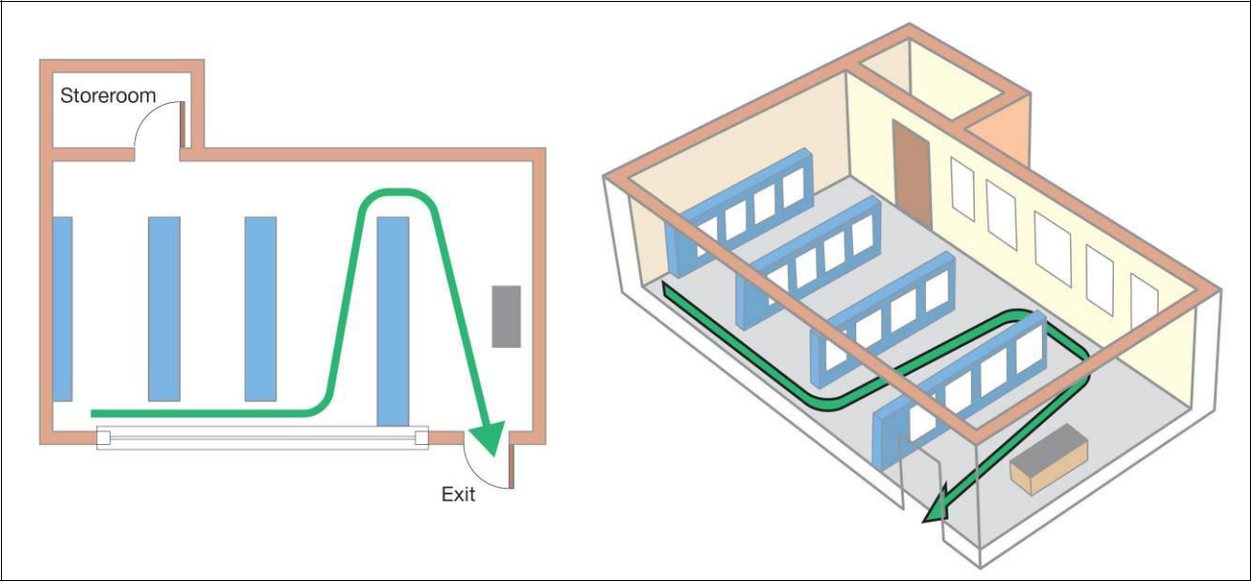

Travel distances should be measured to a place of reasonable safety, that is:

- A protected stairway enclosure

- A separate fire compartment, from which there is a final exit

- The nearest available final exit

If the travel distance is in excess of the norm for the level of risk you have determined, it may be necessary to do any one or a combination of the following to compensate:
- Provide earlier warning of fire using automatic fire detection

- Revise the layout to reduce travel distances

- Remove or reducing combustible materials and/or ignition sources

- Control the number of people in the premises

- Limit the area to trained staff only (no public)

- Increase staff training and awareness

Page 11

Step 4: Calculating the occupant capacity

After calculating your room or premises, and exit capacity as detailed in steps 1 and 2, take the lowest occupancy figure form these calculations as your maximum occupancy capacity figure. Then review the results from your fire exit travel distances (in step 3). If the travel distances are over the suggested travel, distances as in table 2 (page 10), you may need to provide additional fire precaution measures and you may need to reduce your maximum occupancy figure.

Further details about the measures you can take to reduce the risk when travel the distances are is in excess of the norm can be found on page 11 of this booklet.

You will also need to consider the outcomes and significant findings from your fire risk assessment when considering the maximum occupancy capacity.

For more details on completing a fire risk assessment:

Web: https://www.cheshirefire.gov.uk/business-safety/your-responsibilities/fire-risk-assessment

For more detailed information, you can also refer to the HM Government risk assessment guides found at:

Web: https://www.cheshirefire.gov.uk/business-safety/free-templates-and-tools

Please note: This booklet is not a full and extensive method of calculating the maximum occupancy capacity of a premises, and is only a basic guide. Any figure you may arrive at may be reduced by Cheshire Fire and Rescue Service due to the unique circumstances of your premises.

The use of this guide will not prejudice any enforcement action that may be taken by Cheshire Fire and Rescue Service as a result of any fire safety deficiencies found during an audit, and does not automatically demonstrate compliance with the law.

Page 12

