Risk Management Practitioner Guidelines

Produced by: Planning & Performance
(Joint Corporate Services)

Review date: July 2024

Contents

Section 1 – Risk Management Process 2-15

APPENDICIES

Appendix 1 – Practitioners Risk on a Page 16
Appendix 2 – Glossary 18

1 Risk Management Process
Risk is one of life’s few certainties. Nothing is achieved without some element of risk, but often relatively little is done to anticipate, evaluate and manage risk, which means that not enough is done to reduce exposure to hazards. Alternatively, it can mean that potential benefits are not realised because there is some degree of hazard associated with the pursuit of opportunity.
How can we evaluate and balance hazards and opportunities to make well-informed decisions and provide sustainable improvements in service delivery? This question is at the heart of risk management.
The Risk Management process is dynamic and ongoing, and relies on the regular review of risks and the consequent adjustment of the control response.
Risk is defined as an uncertain event or set of events that, should it occur, will have an effect on the achievement of objectives. It can be perceived as either threat or opportunity:
Opportunity: An uncertain event or set of events that, should it occur, will have
Positive effect on the achievement of objectives.

Threat: An uncertain event or set of events that, should it occur, will have a negative
effect on the achievement of objectives.
CFRS Vision, Mission and Objectives
The focus for the Fire Authority remains clear and it is to make Cheshire a safer place. This is articulated in our vision and mission statements, underpinned by a set of strategic aims and objectives.
Our Vision:
A Cheshire where there are no deaths, injuries or damage from fires or other emergencies.
Our Mission:
To help create safer communities, to rescue people and protect economic, environmental and community interests.

Our Strategic aims and objectives:
To protect our communities and reduce local risks we will:
- Maintain a detailed understanding of our communities and carry out risk analysis and assessment to identify the people and property most at risk;
- Deliver campaigns and projects to reduce antisocial behaviour and increase awareness of fire and road safety;
- Ensure fire safety legislation is implemented effectively.
To respond promptly and effectively to emergencies we will:
- Ensure plans and resources are in place to provide a flexible, efficient and resilient response to emergency incidents;
- Use intelligence and data to match resources to risk and demand;
- Ensure the safety of our people by providing them with the right equipment, training and skills.
In developing an excellent organisation accountable to our communities we will:
- Ensure our workforce is competent and able to deliver our vision;
- Inform and involve our communities and our staff in developing services and policies which are open, transparent and accountable;
- Deliver value for money services which maximise community safety and minimise our impact on the environment.

The CFRS Risk Management Process
The basis of Cheshire Fire & Rescue Service’s methodology is a four step cycle:
- Step 1 - Identify risks aligned to organisational objectives;
- Step 2 - Assess & prioritise them;
- Step 3 - Plan & implement response;
- Step 4 - Review & report.
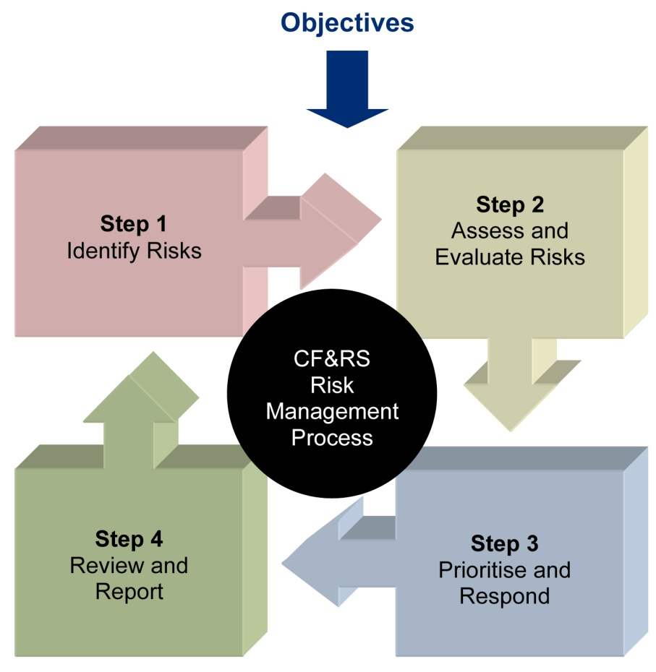
Step 1
Identify Risks
Step 3
Plan & Implement Response
Step 2
Assess & Prioritise Risks
Step 4
Review & Report

The main focus should be on the achievement of objectives rather than the assessment process itself. Too little awareness and control can damage the performance of any organisation, but an obsessive level of involvement in the fine details of risk could easily overwhelm the organisation.
It is worth remembering that the amount of work conducted in assessing and managing risks should be proportionate with the intended outcomes and benefits of delivering the objective.

Step 1
Identify Risks

In the risk identification process we are looking to specify the events that could impact on business objectives, whether this is the strategic plan or Service and community plans. This may have a positive effect or a negative impact, and there are 3 parts to a risk – an event that has a consequence that leads to an impact on our objectives.
CFRS encourages the following methods for the identification of significant risks:
- Horizon scanning / forecasting – assess and understand the wider context; learn from previous experience and the experiences of others where possible. CFRS conducts a regular PESTELO (Political, Economic, Sociological, Technological, Environmental, Legislative, and Organisational) analysis as part of the strategic planning cycle, as this is an important step in the risk identification process.
- Bring stakeholders together to identify, analyse and prioritise significant risks within the specified activity.
- Use techniques such as ‘brainstorming’ to identify all potential risks.
Once identified, risks that are significant enough to warrant action are recorded on the CFRS the ‘Cheshire Planning System (CPS) with control measures identified and risk owners allocated.
Early Warning Indicators (EWIs)
Given that risks may or may not occur, monitoring certain metrics helps the Service recognise that a risk or set of risks might be about to materialise. These Early Warning Indicators (EWIs) enable the Service to be proactive in dealing with a risk before it happens, rather than reacting to it when it does.
CFRS have a number of methods for identifying risk triggers. Environmental and horizon scanning/forecasting and PESTELO analysis which help to identify strategic risks that may affect the environment in which the Service operates. Monitoring a suite of performance indicators and identifying changes or emerging trends supports the identification of emerging risks or changes to the likelihood or existing risks occurring. The Service can then put plans in place to mitigate or respond to those risks before or as they materialise.
Drivers of Risk
The risks that CFRS faces can result from both internal and external factors. The following list outlines some key drivers of risk, i.e. ‘the things we do’, but the list is not exhaustive:
- Prevention and Protection
- Compliance to Legislation
- Community Engagement
- Partnerships
- Employment
- Financial Management
- Health & Safety
- Operational Response
- Procurement
- Technology
- Training & Development
- External Environment
- Change Management
Opportunities rather than threats
If threat risks are those we would want to mitigate, then opportunity risks are those that we might wish to maximise. Opportunity risk can be about identifying the potential to do things better to increase the benefits of an activity. This is important for an organisation that values continuous improvement. Managing opportunity risks means taking control of uncertainty and increasing the likelihood of a positive outcome or improving the impact.
Opportunity risks are often missed due to the common perception that risk is negative. Identifying positive risk requires a proactive approach and most benefit can be gained from applying opportunity risk management in the early planning stages of any operational activity, project, and programme or in strategy formulation – this is where decisions can be made most easily about whether and how to exploit/enhance the opportunity.
In addition, if we focus on opportunities when assessing the merits of different possible responses, this often allows us to look at bolder, more creative or innovative solutions – essentially to take greater but calculated risks.
Thematic Risks
As part of the risk identification process we have the opportunity to assign themes to our risks; this allows us to group risks that have commonality and address and monitor them together through the relevant forum. Each theme has been allocated an owner and, where applicable, the owner is the Chair of a relevant Group, e.g. Equality & Diversity Task Group.
CFRS thematic risk registers:
- Financial
- Reputational
- Operational
- Health & Safety
- Partnership
- People
- Project
- Environmental
- Equality &Diversity
- Business Continuity
The themes are applied when recording the risk registers on the Cheshire Planning System and consideration needs to be given on the impact to the organisation when scoring thematic risks.

Step 2
Assess & Prioritise Risks
Once the risks have been identified, the first action is to consider what existing controls are in place: we refer to these as current controls.
The current controls are those that are in place at the time the initial risk assessment takes place: these may be in the form of current policies, processes, procedures, systems etc. It is the responsibility of the risk owner where practical to assess the ‘current controls’ and ensure they are relevant and fit for purpose.
An assessment should then be made about which risks are going to pose the greatest threat (or opportunity). We do this by looking at both the likelihood and impact. Simply put, as the likelihood and severity of impact increases so does the measure of risk.
By considering the consequence and probability of each of the risks we have identified, we can begin to prioritise which of these risks we need to look at in more detail.
Scoring the risks
Once the current controls have been identified, an assessment of how soon the event could occur (likelihood) and the effect it would have on the organisation (impact) is required. The multiplied combination of these two factors (likelihood x impact) provides an overall risk score.
CFRS use the standard scoring model of 1-5 where a score of 1 represents very low probability of occurring or negligible impact, and 5 represents an imminent event or catastrophic consequences. The following tables should be used for guidance when performing the risk assessment, however, the context of the risk is an important consideration so an element of professional judgement should be used in relation to the activity/objective with which it is associated. When scoring risks please also bear in mind the duration of recovery. Risk as opportunity needs to be thought through in a similar manner: for example, major impact on publicity or finances could be a positive one.
Inherent Likelihood
Likelihood | Description | Commentary
1 | Very Low | - Is thought to have occurred in the past or not yet occurred to date  - Expected to be a rare occurrence
2 | Low | - Has occurred a few years ago  - May happen in the short to medium term
3 | Moderate | - Occurs every couple of years in the organisation  - There is a reasonable probability that it will occur in the short to medium term
4 | High probability | - Has occurred in the past year  - There is a strong probability that it will happen in the next 12 months
5 | Very Likely | - Has happened recently or happens frequently in the organisation  - Almost certain to occur in the near future

Inherent Impact
Impact | Description | Commentary
1 | Negligible | - Minimal problems in delivering corporate objectives  - No noticeable disruption to normal service  - Little or no financial implications <£5k
2 | Low | - Minor problems in delivering corporate objectives  - Minor disruption to delivery of service  - Some financial loss >£100k
3 | Moderate | - Problems in delivering corporate objectives  - Noticeable disruption to important services  - Some financial loss >£250k
4 | Major | - Inability to deliver one of the corporate objectives  - Major disruption to important services  - Major financial loss >£500k
5 | Catastrophic | - Inability to deliver a number of corporate objectives  - Major disruption to critical services  - Major financial loss >£1M

Note: The financial impacts above relate to scoring of Strategic risks.
Projects will have an approved tolerance + - 10% of the project budget Projects less than £50,000 will be escalated to Performance & Programme Board at the discretion of Strategic Change (Joint Corporate Services) and/or Head of Finance.

CFRS calculates inherent impact as being the potential on the organisation now, should the risk materialise with the current (inherent) controls in place.
To obtain some consistency of scoring across the organisation it is important that risk owners assess the impact of the potential risks at an organisational level. This will enable comparisons between risks to be made easily and allow the risk profile of the Service to be analysed effectively.
So when thinking through the implications of an identified risk, ‘loss of key staff’, for example, may appear to a department head as potentially having a major impact to the team objectives, but to the organisation it may be classed as minor impact depending on the role. It is important to bear in mind the impact on the organisation when scoring departmental risks. Those department risks that attract a high score when assessed in this manner are likely to be considered by the Risk Management Board for escalation to the Strategic Risk Register.
Opportunity Impact Assessment
In relation to opportunity risk, the following guidance is provided to assist the assessment of the potential positive impact to the organisation.
Impact | Commentary
1 | - Very little improvement in the delivery of normal services  - Minimal benefit  - Income/Saving <£5k
2 | - Improved ability to deliver normal services  - Some additional benefit  - Income/Savings >£100k
3 | - Improved ability to deliver important services  - Notable increase in benefits / outcomes  - Income/Savings >£250k
4 | - Significant improvement in the delivery of important services  - Significant increase in important outcomes  - Income/Savings >£500k
5 | - Improved delivery of critical services  - Major increase in benefits / strategic outcomes  - Income/Savings >£1M

Prioritisation
The overall inherent risk rating is calculated by multiplying the likelihood score with the impact score and a RAG system is applied as shown in the matrix below. Scoring facilitates the prioritisation of risks.
Probability/  Likelihood | VH = 5 | 5 | 10 | 15 | 20 | 25
 | H = 4 | 4 | 8 | 12 | 16 | 20
 | M = 3 | 3 | 6 | 9 | 12 | 15
 | L = 2 | 2 | 4 | 6 | 8 | 10
 | VL = 1 | 1 | 2 | 3 | 4 | 5
 |  | VL = 1 | L = 2 | M = 3 | H = 4 | VH = 5
 | Impact
Likelihood x Impact = Risk Rating
If a risk carries an overall score of 15 or above (Red), it is deemed to be of highest priority, requiring a robust plan and consideration for escalation to the Strategic Risk Register. Medium risks have a score between 9 and 14 (Amber) and require a planned managerial response. Scores of 8 or below (Green) are considered low and may need minimal action.

Risk Score | Level of Priority | Threats | Opportunities
15-25 | High | Treatment should commence immediately – consider escalation to Strategic Risk Register | Opportunity should be exploited immediately
9-14 | Medium | Treatment should be applied as soon as reasonably practicable | Opportunity should be exploited as soon as reasonably practicable
1-8 | Low | Treatment is not essential as risk can be tolerated | Exploiting this opportunity is not essential as the benefits would be negligible
Step 3
Plan & Implement Response

Now the high level identification and prioritisation of risk has taken place, we need to identify what further measures we will have to take to lower the risk to an acceptable level within reasonable costs, (with opportunities, you should be looking for ways to maximise them).
Risk Treatment
Risk treatment involves assessing the range of options for responding to identified risk, preparing risk response plans and implementing them. In order to manage risks efficiently the minimum amount of treatment to manage a risk to an acceptable/ desired level should be applied.
When considering appropriate response options, it may help to ask these three questions:
- Can we reduce the probability of the risk occurring?
- Can we reduce the magnitude of loss?
- Can we change the consequences of the risk?
Most risks cannot be eliminated altogether and risk management involves making judgements about what level of risk is acceptable.

CFRS recommends six options for response:
Response
- Mitigate | Steps taken to reduce either the likelihood or impact or both.
- Transfer | Some risks can be transferred to an insurer e.g. legal liability, financial impact, property, vehicles, etc. Service delivery risks can be transferred to a partner. Some risks cannot be transferred e.g. reputational risks.
- Accept | Informed decision to accept likelihood and impact
- Exploit | Steps taken to leverage the situation and turn threats into opportunities or to ensure that any potential benefits are realised / maximised.
- Avoid | Stop doing the activity or find different ways of doing it, introduce alternative systems/practices.
- Monitoring | Keep risk under review for a period of time before closing
Resourcing risk reduction activities
Some measures will be relatively easy to implement; others may have bigger budgetary/resource implications and may need a phased approach. Risk treatment measures may be identified that fall outside the risk owner’s immediate area of influence, e.g. another department, in which case any risk treatment plan should be developed in conjunction with all relevant areas of the organisation, appropriately communicated and actions need to be allocated to individuals and regularly monitored for progress. The risk owner is responsible for overseeing progress of all identified actions.
Scoring risk improvements
An assessment should be made about what the risks will look like after the risk treatment plan has been implemented – to see how effective they are likely to be – this is known as Residual Risk. The risk scoring exercise above is repeated taking into account the impact of the proposed additional control measures/improvements, and the new score entered onto the Cheshire Planning System as the target rating. The Residual Risk is the target result that the risk treatment plan should be designed to achieve.
Control effectiveness
Many of the risks identified will already have controls in place or will require additional controls to manage the risk to an acceptable level. It is important to ensure that these controls are working effectively through periodically assessing how they are working in practice. The table below provides some guidance.
Effective | Controls in place provide significant assurance in mitigating the risk to an acceptable level
Partially effective | Provides a limited level of assurance in mitigating the risk, however further mitigation actions need to be assigned to manage risk to an acceptable level.
Not effective | Controls in place are not effective. Action plan needs to be put in place immediately.

Contingency
Contingency arrangements should be considered, particularly for significant risks – these are the actions that will be taken or processes to be implemented in the event that the risk occurs, for example Crisis Management Plan. The contingency arrangements should be entered into the risk record on the Cheshire Planning System.
Recording
The Cheshire Planning System is a dynamic environment which holds all CFRS risk registers. All of the response actions identified as part of the risk treatment plan should be recorded on the risk registers in the Cheshire Planning System and should then be effectively managed. Risk owners can assign mitigating actions to be delivered but need to continue to monitor and record progress against the management of each risk on their risk registers using the Cheshire Planning System to facilitate this.

Escalation and demotion process
If the risk cannot be managed at the level at which responsibility has been assigned, risk owners should escalate the risk for consideration at a higher level.
Illustration of risk escalation process
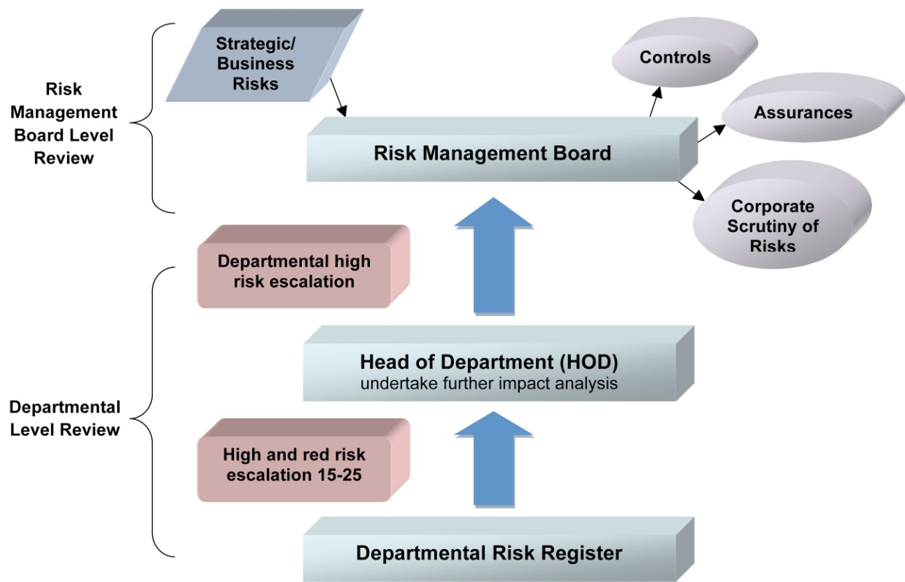

Risks can also be demoted if sufficient action has been taken which has reduced the likelihood and/or impact of the risk on the delivery of our corporate objectives.
All significant risks scoring 15-25 should be considered as major and will need to be discussed with the Head of Department who, after further impact analysis, will make the decision whether to escalate it to the Risk Management Board for inclusion on the Strategic Risk Register. Once the decision has been made to escalate a risk, the risk should be tabled for discussion at the next Risk Management Board.

Step 4
Review & Report

Risk reporting is important to provide assurance to management, Members of the Fire Authority, and stakeholders, that the organisation understands its risk profile and responds to risk in an efficient manner that facilitates the effective, well managed achievement of objectives. It is integral to performance management. Risk reporting can guide positive behaviour as successes are recognised and lessons learnt, thus encouraging continuous improvement. The Risk Management Policy (can be assessed below) provides the overall direction for risk management within the Fire Authority
Organisational Risks
Cheshire Fire & Rescue Service Strategic Risk Register is reviewed:
- Regularly by the individual risk owners;
- Quarterly by Head of Department facilitated by the Planning & Performance team (Joint Corporate Services)
- Six monthly by the Risk Management Board;
- Annually by the Fire Authority.
Departmental Risks
On a regular basis, risks should be monitored and progress reviewed by the relevant risk owners and Head of Department to ensure they remain operational and relevant. Team and departmental meetings will need to include regular monitoring of the status of risks and the treatment plans put in place to manage the risk. This risk tracking process is essential to managing risks effectively. Each department has a nominated Risk Champion who will provide the check and challenge role and support assurance that the controls put in place are effective.
Risk monitoring is not just about practitioners convening on a monthly or quarterly basis to discuss their risks and risk registers, amending records and filing outcomes until the next meeting. Risk monitoring is about constantly applying the risk management techniques to drive performance on a ‘business as usual bases. The management of risk should be an enabling process focused on the achievement of objectives.
Project Risks
Project risks are associated with specific projects. Any project will go through a life cycle, for example, conception to scoping, planning, implementing, testing and delivery. Project risks exist at every stage, and they need to be identified and managed to ensure the successful completion of the project.
Risk identification for projects and activities forms part of the project initiation and planning processes where potential issues and opportunities are identified by the project team(s).
For project risks, mitigating actions will need to be developed and managed by the relevant project managers and recorded on the project risks log. Any project risks scoring high or very high will need a risk register populated on the Cheshire Planning System. The Project Management Framework also includes some guidance on project risks.
The Project and Performance Board has responsibility for overseeing significant programmes and Projects and risks will be reported to this Board for review, scrutiny and challenge.
Partnership Risk
Partnerships represent an increasingly common model of service delivery and can range from multi-million pound, multi-agency arrangements between various sectors, through to one-off, very small scale, local ‘arrangements’. The level of risk inherent in each partnership will vary accordingly and a proportionate level of risk management techniques applied.
The Service has produced a Partnership Policy which offers guidance when setting up a partnership agreement. The complexity and formality of the risk management arrangements should be considered as part of developing the partnership governance arrangements, but proportionality is the watchword – for a one off partnership where liabilities run to say a few hundred pounds, then it is sufficient to have a single sheet with a few lines to identify the major risks and how they will be controlled. Larger partnerships will require increasingly more formal arrangements, perhaps up to and including a full risk register, agreed, and reviewed at specified periods, reported to the governing body of the partnership.
Risk Reporting and Monitoring
CFRS has a number of forums that measure, monitor and address organisational performance in terms of risk response:
ROLE/FORUM | RESPONSIBILITY
Risk Management Board (RMB) | Officer and Member group, chaired by the Chief Fire Officer, that meets six monthly to identify, assess, monitor and review Strategic risks and ensure they are managed and updated in line with the Risk Management Policy. The Strategic risks recorded within the Service’s Cheshire Planning System will be used to determine the Authority’s levels of balances and reserves. The Board also reviews those departmental risks that are scored as high priority (Red risks).  Risk Management Annual Report is received by the Board annually prior to being presented to Performance & Overview Committee.
Performance & Programme Board | Officer group, chaired by the Chief Fire Officer, providing scrutiny and assurance on significant programmes, projects and associated risks and the impact on the Service.  This group also has responsibility for driving service improvement through the monitoring of organisational performance, agreeing remedial action as necessary and identifying areas of good practice. This group monitors a range of key performance indicators, some of which measure outcomes relating to CFRS risk reduction activities. This group: monitors trends in community risks and the Service’s performance in responding to them; generates Service delivery initiatives aimed at reducing risk across the Unitary areas of Cheshire and responding to specific issues as they arise during the year.
Budget Management Board (BMB) | Officer group, chaired by the Joint Head of Finance. The Board monitors the CFRS financial risk register and assesses the effectiveness of controls and forms part of the quarterly Service Management Team (SMT) meetings.
Service Management Team (SMT) | Quarterly review and challenge of departmental risks across the organisation.
Fire Authority | Three yearly presentation and approval of the Risk Management Policy. Final approval of the Internal Audit Plan and receive annual report of outcomes from delivery of the audit plan.
Performance & Overview Committee | Receive the Risk Management Annual Report, quarterly progress reports against organisational plans and Internal Audit Plan for scrutiny as part of the corporate performance reporting process.
In addition, thematic risk registers should be reviewed by the relevant steering group or Board, for example the Equality Task Group; Performance & Programme Board or Health & Wellbeing Board, to monitor progress and effectiveness of risk response.
Measurement of the effectiveness of Risk Management
Risk Management should be considered an integral part of how an organisation achieves its objectives effectively and efficiently. The effectiveness of the process can be assessed by:
- the quality of risk information input by the risk owns and planning & performance team on the Cheshire Planning System;
- changes to inherent risk scoring;
- the number of strategic and departmental risks which have occurred and the associated losses/gains;
- the number of new strategic and departmental risk registers added to the Cheshire Planning System;
- timely risk escalation to the appropriate level;
- timely achievement of target risk rating;
- Risk owners’ understanding of the process and the guidance (people trained);
- Positive audit opinions.
Audit and Assurance
A review of the Risk Management Policy is undertaken every three years.
Internal Audit are commissioned periodically to undertake a Risk Maturity assessment to provide assurance to our stakeholders on the extent to which a robust risk management approach has been adopted, applied and planned by Cheshire Fire & Rescue Service in identifying, assessing, responding to and reporting on opportunities and threats that have an impact on the achievement of our objectives.
Quarterly reviews of the risk registers on the Cheshire Planning System are undertaken with the Performance, Planning & Risk Officer (Joint Corporate services) and the Heads of Department.
The Risk Management Annual Report is received by Risk Management Board for review and approval prior to being presented to Performance & Overview Committee annually.

APPENDIX 1 - Practitioners Risk on a Page
In this section we include some risk management tools that you may find useful during various phases of managing risk.

Step 1:  Identify Risks | Step 2:  Assess & Prioritise Risks | Step 3:  Plan & Implement Response | Step 4: Review and Report
Objective-driven:  Relate risks to the impact they will have on your intended objectives, activities and outcomes:  - what are we trying to achieve  - where are we going  - what are the proposed outcomes  ■ Risk: something that may have an impact on the achievement of your objectives or outcomes. It includes risk as an opportunity as well as a threat. An example of a risk opportunity maybe:  Delivering services through partners like Safe & Well can bring significant benefits, but there is less direct control. Partnerships can lead to higher levels of uncertainty and introduce different (and therefore unfamiliar) risks into the organisation.  Thematic Risks: financial, operational, project, reputational, legal, data * information, business  Continuity, equality & diversity, environment ; ICT; opportunity; workforce & people and health & safety  Each thematic risk register  has an owner within the  organisation.  Gathering intelligence:  Through horizon scanning (identify potential risks/threats and opportunities and be better prepared), surveillance and stakeholders.  Risks can be identified from bottom-up and from top-down. From the bottom, risks will be identified and assessed where they occur (by any member of staff) and will then be captured in departmental or strategic risk registers as appropriate. | Consequences:  Political, financial, societal, operational, legal, environmental, reputational  Risk rating: the classification of each risk, based on its likelihood and potential impact to the objective or outcome. The matrix below is the 5x5 model:  Probability/ Likelihood VH = 5 5 10 15 20 25  H = 4 4 8 12 16 20  M = 3 3 6 9 12 15  L = 2 2 4 6 8 10  VL = 1 1 2 3 4 5  VL = 1 L = 2 M = 3 H = 4 VH = 5  Impact  ■ Risk scoring:  Likelihood- the evaluated probability of a particular outcome actually happening  VH 5 = Almost Certain  H 4 = High probability  M 3 = Possible  L 2 = Low probability  VL 1 = Unlikely  Impact – the evaluated effect or result of a particular outcome actually happening  VH 5 = Catastrophic – inability to function  H 4 = Major – significant impact on delivery  M 3 = Moderate – objectives partially achieved  L 2 = Minor – minor impact on objectives  VL 1 = Negligible – minimal impact, no  Disruption.  Escalating Risks:  Overall Rating  1-8 Manageable Risks  May not need to consider the risk appetite nor proceed any further with the assessment but merely record that the risk has been identified and that due to its low likelihood or impact no further action will be required.  9-14 Material Risks  These risks need to be managed by the department in which they have been identified.  15-25 Significant Risks  These risks should be considered as major and need to be discussed with the Head of Department who, after further impact analysis, will decide whether they need escalation to the Risk Management Board for consideration as strategic Risks, which are monitored and managed at the highest level of the organisation. Escalation can be direct to a member of the Leadership Team if deemed urgent, or via Legal & Democratic Services for inclusion on the next RMB Agenda. | Mitigate: steps taken to reduce either the likelihood or impact or both  Transfer: steps taken to shift the loss or liability to other parties, ensuring the risk is owned by appropriate party  Accept: Informed decision to accept likelihood and impact  Exploit: steps taken to leverage the situation and turn threats into opportunities  Avoid: steps taken to prevent occurrence of hazards  Monitoring: keep risk under review for a period of time before closing  Managing Risk:  - Current Controls: control measures currently in place to manage risk to an acceptable level  - Residual Controls: additional controls identified to reduce the likelihood and impact  - Contingency: an action or arrangement that can be put in place to minimise the impact of the risk when it has gone wrong | Risk Registers: these risk registers are developed on the Cheshire Planning System and are a record of identified risks which are monitored & managed regularly by assigned risk owners  Risk Levels:  Strategic ‘Top Risks’:  these risks are key to the delivery of the Service objectives; kept under regular strategic review by the Risk Management Board  Department risk: the key risks to the delivery of a department’s objectives kept under regular review by senior managers  Embedding: changing working practices to ensure good risk management is evident and sustained throughout the organisation  If your Team is not required to formally record risk at least develop the mind-set. Think Risk Consider & Select Options, Implement & Review.  Risk Management should be an intrinsic part of our business planning and decision making process. No change of direction, outcome or objective should occur without first considering the potential risks involved and the impact on the organisation.  We have embedded Risk Management into the planning process for the development of IRMP, departmental and unitary area plans and even considered at project level.

APPENDIX 2 - This glossary is not exhaustive, but covers the terms used in this Policy and Practitioners guides:

Assurance | Independent confirmation that risk assessments and control responses are appropriate.
Compliance | Complying with laws and regulations applicable to an entity.
Controls | Actions in place to reduce the likelihood and or impact of risk.
Corporate Governance | Framework of accountability which organisations take decisions, lead and control their functions. Corporate governance includes management structures, risk management, reporting, audit, scrutiny and assurances.
Impact | The effect of a risk should it occur.
Liability | A legal responsibility for something, (e.g. responsibility to pay compensation).
Likelihood | The anticipated frequency with which a risk is expected to occur.
Opportunity | An uncertainty of event or set of events that, should it occur, will have a positive effect on the achievement of objectives.
Risk | The chance or something uncertain happening that will have an impact upon objectives, positive, (opportunity), or negative (threat).
Risk Appetite | The level of risks that organisations are prepared to accept in the delivery strategic objectives.
Risk Identification | The process of determining what can happen, why and how.
Risk Owner | The person assigned to manage the risk including monitoring the risk, its controls and any treatments.
Risk Register | Record containing details of identified risks, risk scores, controls put in place, risk owner and progress in managing the risks.
Risk Scoring | The process of assessing and quantifying the probable impact and likelihood this is done using a 5 x 5 matrix.
Risk Treatment | Action taken to mitigate the risk.
Risk Transfer | Assigning the responsibility to another party through legislation, contract, insurance or other means.
Risk Tolerance | The acceptable variation relative to the achievement of objectives.
Threat | Uncertainty event or set of events that, should it occur, will have a negative effect on the achievement of objectives.
Uncertainty | Inability to know in advance the exact likelihood of future events.

