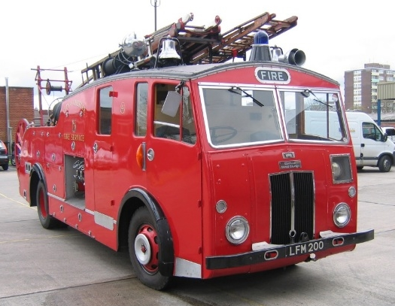
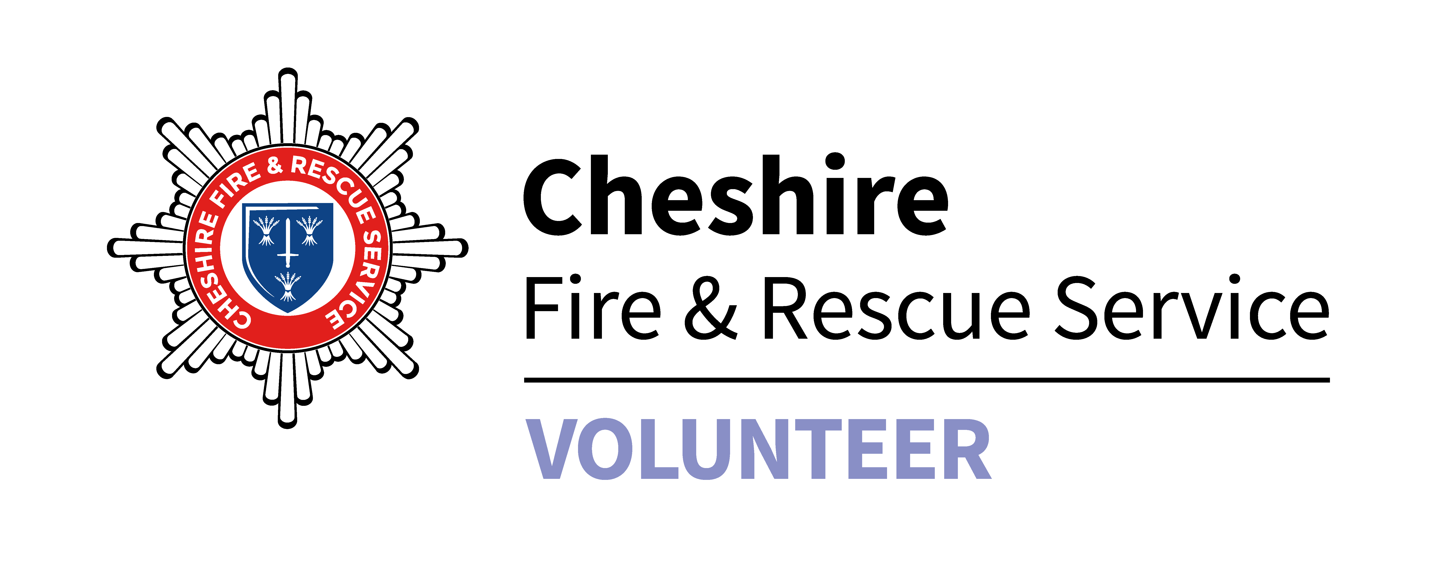

CFRS Heritage Vehicle Booking Request Form

If you would like a Cheshire Fire and Rescue Service vintage vehicle to attend your event, please complete the form below and return to the Volunteer Coordinator, Sadler Road, Winsford, Cheshire, CW7 2FQ claire.bennett@cheshirefire.gov.uk

As it can take some time to secure a driver and arrange vehicle availability, please give a minimum of one month's notice prior to the event. Insurance documents are available on request.

1. Details of event organiser
Title |  | First name |  |  | Surname
Mobile Number
Landline Number
Address 1
Address 2
Town |  |  |  | Postcode
Email Address

2. Contact details of person to contact on the day (if different from above)
Title |  | First name |  |  | Surname
Mobile Number
Landline Number
Address 1
Address 2
Town |  |  |  | Postcode
Email Address

3. Event Details
Type / Name of event
Date of event
Location Address 1
Address 2
Town |  |  | Postcode
Time of event | Start |  |  | Finish

7. What will happen next?

Once we can confirm the availability of a vintage vehicle the booking will be added to the heritage diary and sent to our volunteers, as soon as we secure a volunteer driver, CFRS will contact you to confirm the booking. All requests will be on a first come first served basis.

PLEASE NOTE: This is NOT confirmation of a CFRS vintage vehicle attending your event.

