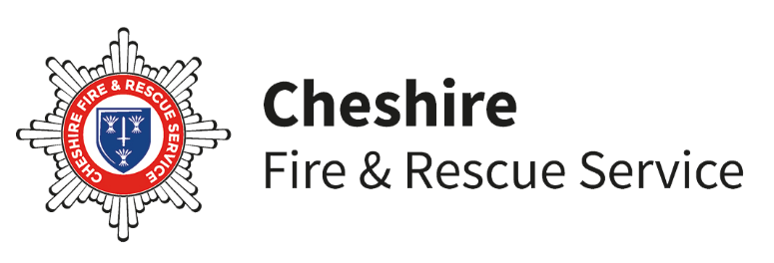

Primary RESPECT

**JOINING CONSENT FORM**

Dear Parent / Guardian,

Can you please fill in the form below in BLOCK CAPITALS.

Name of Young Person ____________________________________________________

Date of Birth ___________________________________________________

Address _________________________________________________________________

Emergency Phone Number _____________________________________________

School ___________________________________________________________________

I agree to my son /daughter/ward to become a member of the **Cheshire Fire and Rescue Service Primary RESPECT programme.** This course may include the following activities:

* Blind trail, team communication exercise
* Fire and road safety awareness sessions
* Fire drills wearing personal protective equipment

Please inform us if you wish to remove your child from any of these sessions, or to receive a full list of sessions booked for the team prior to the course beginning.

**Cheshire Fire and Rescue Service** obtains, holds and uses the personal data requested from you in complete confidence for research and evaluation purposes. **All data will remain confidential**.

**SIGNED / DATED** ------------------------------------------------------

**PHOTO CONSENT FORM**

As you may be aware when joining the RESPECT scheme, part of the programme involves doing some activities within the Fire and Rescue Service. This could involve public events where the Fire Service and or press would like to take photographs. On occasions we would also like to use photographs for promotional materials and possible inclusion on Cheshire Fire & Rescue Service’s web site.

Could you please indicate whether you agree or disagree to your child being included in photos of Cheshire Fire and Rescue Service activities:  **Agree**  **Disagree**

Signed……………………………….parent/guardian Date……………………………

**MEDICAL CONSENT FORM**

It may be essential for your child to receive medical treatment whilst participating in the RESPECT scheme. We ask for your consent to allow us to contact the relevant medical practitioner on your behalf in the event of an emergency.

Date of last Tetanus (approx) _____________________________________

Does your son / daughter suffer from any of the following?

1. Asthma
2. Allergies
3. Seizures
4. Diabetes
5. Hay fever
6. Any hearing conditions
7. Any other medical conditions/support needs

If so, please give details including any medications

_________________________________________________________________

_________________________________________________________________

**DECLARATION**

I, ______________________________the Parent/Guardian of _______________________

**Agree**  **Disagree** to the child receiving any emergency treatment, dental, medical or surgical (including administration of anesthetics) that may be advised by a doctor during my Childs participation in Cheshire Fire and Rescue Service **RESPECT** scheme. It is imperative for the health and safety of your son/daughter that any changes in their health which may affect their performance in carrying out their duties as a participant, should be brought to the immediate attention of their leaders.

**SIGNED / DATED** _______________________________________________