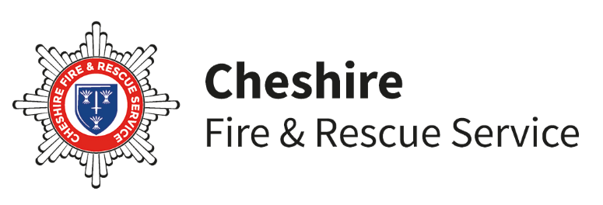

**Joining Consent Form for Youth Programme**

Please email the completed form back to your team leader or christine.mitchell@cheshirefire.gov.uk

|  |  |  |  |
| --- | --- | --- | --- |
| **Student Details** | | | |
| Name of Young Person: |  | | School:  Phone no. |
| Date of birth: | Gender: M/F | Parent/Carers Name and Address & postcode:  **Email for Graduation invitation (Please write clearly)** | |
| Emergency Contact details:  Name/ Relationship to young person:  Tel: email: | | | |

I agree that the above student can become a member of the **Cheshire Fire and Rescue Service Youth programme.** This course may include the following activities:

**Fire Safety**

**Road Safety**

**Drug & Alcohol Awareness**

**Mental Well-Being**

**First Aid**

**Healthy Relationships (Including sexual health)**

**Cyber Safety**

**Confidence Building**

**Team Work**

Please inform us if you wish to remove your child from any of these sessions, or to receive a full list of sessions booked for the team prior to the course beginning.

Please also refer to the **‘Personal Data – Explained’** document to find out how Cheshire Fire and Rescue Serviceobtains, holds and uses the personal data requested from you.

Signed………………………………. parent/guardian Date……………………………

**PHOTO CONSENT FORM**

As you may be aware when joining the course, part of the scheme involves doing some activities within the Fire and Rescue Service, this could involve public events where the Fire Service and or press would like to take photographs. On occasions, we would also like to use photographs for promotional materials and possible inclusion on Cheshire Fire & Rescue Service’s web site.

Could you please indicate whether you agree or disagree to your child being included in photos of Cheshire Fire and Rescue Service activities:  **Agree**  **Disagree**

Please indicate whether you agree or disagree to your child being included in photos for their personal portfolio and course graduation presentation.  ***Once this is complete all photos containing your child will be deleted***:  **Agree**  **Disagree**

Signed……………………………….parent/guardian Date……………………………

**MEDICAL CONSENT FORM**

In the unlikely event that your child requires medical treatment whilst participating in the scheme, we ask for your consent to allow us to contact the relevant medical practitioner on your behalf in the event of an emergency and to administer any necessary first aid.

Doctors name and address __________________________________________________

Does your son / daughter suffer from any of the following?

1. Asthma
2. Allergies
3. Seizures
4. Diabetes
5. Hay fever
6. Any hearing conditions
7. Any other medical conditions/support needs

If so, please give details, including any medication ___________________________________________________

_________________________________________________________________________

Does your son/daughter have any special dietary requirements? ______________________

_________________________________________________________________________

I, the Parent/Guardian of ___________________________

**Agree**  **Disagree** to the child receiving any emergency treatment, dental, medical or surgical (including administration of anesthetics) that may be advised by a doctor during my childs participation in Cheshire Fire and Rescue Service Youthscheme It is imperative for the health and safety of your son/daughter that any changes in their health, including pregnancy, which may affect their performance in carrying out their duties as a participant, should be brought to the immediate attention of their leaders.

**SIGNED / DATED** ------------------------------------------------------------------